# **Transition to the LACES Database**

This fourth transition document provides Virginia adult education providers, as subrecipients of the Virginia Department of Education’s (VDOE) administration of WIOA Title II, with information about expectations and timelines as the VDOE transitions databases used for state and federal reporting. Other transition documents will be issued as needed; be sure to watch for announcements of new editions added to the [Data, Monitoring, and Evaluation](https://www.doe.virginia.gov/teaching-learning-assessment/specialized-instruction/adult-education/data-monitoring-evaluation) webpage.

In April 2024, Virginia required all providers to transition adult education data entry to the LACES database, developed and maintained by LiteracyPro Systems, part of GeniusLearning.

## System Administrators

Providers may request an additional system administrator if this is necessary; the request should come from the Program Manager with a justification to [helpdesk@literacypro.com](mailto:helpdesk@literacypro.com) with a cc to [OAEL@doe.virginia.gov](mailto:OAEL@doe.virginia.gov). The LACES team will consult with the state Office on these requests. Such requests should be made with prudence and provide sufficient justification of why it is necessary to have more than one System Administrator in the agency. To fulfill the request, the new System Administrator will need to follow the instructions in Transition Document #1 and in the User News Account Management to have a unique email address (not their primary work email address).

We have also received requests for a training for System Administrators and have requested a recorded tutorial from the LACES team that will be posted in the User News section of LACES. We will announce when it is posted.

## Training Database and Future Trainings

A small Data Analysis Workgroup is populating the LACES training database with more realistic student, class, and staff records. This will support several trainings conducted by the Workgroup through this program year. The first Workgroup training will be a session at the VAACE conference. Mark your calendars and watch the VALRC [Events](https://valrc.org/events/) calendar for a link to the second training on January 14, 2025, 2-3:30 p.m. These trainings will be focused on using the data analysis features for local program monitoring and continuous improvement.

If your region is planning a local training or procuring a training by the LACES team, be sure to inform and involve the state Office so that we can coordinate opening the training database for your use and have one of the state staff attend if at all possible.

## Integrations Must Be Monitored

Integrations with assessment scores must be monitored closely to ensure there are no missed records. This monitoring should be instituted locally and become part of providers’ internal controls such that data entry staff are watching LACES student records and checking them against local intake and assessment staff records or test publishers’ records. Some reasons why a score may not populate during an integration include a students’ last name or birthdate on the assessment record not matching exactly to the corresponding fields in LACES. Also, downloading the student diagnostic report and noting any students without an assessment following assessment events may help catch potential non-integrated information.

## Staff Records

If you have a new staff member this program year, the LACES database will not recognize a Years of Experience entry of zero (until there is an announced fix). Enter a small decimal of time such as 0.1 or 0.2 that can be recognized as Less than One Year of Experience.

## What Element is “Hold Harmless” PY2024-2025?

It was announced in the *NRS Changes and New MSGs* recorded tutorial that PY2024-2025 is a “hold harmless” year for the post-test rate on the program risk rubrics. The risk rubric is used by the state Office to monitor program performance and is not a required reporting element to the federal Office. The post-test rate on the risk rubric is the only element that is “hold harmless” this year. All NRS performance indicators remain set by the targets negotiated with the U.S. Department of Education. These can be found in the [*Program Managers Responsibilities Manual*](https://www.doe.virginia.gov/home/showpublisheddocument/34750/638594150774600000). Find the recorded tutorial and transcript on the [Professional Development](https://www.doe.virginia.gov/teaching-learning-assessment/specialized-instruction/adult-education/professional-development) webpage.

## Data Entry for Alternative Placement

When adding a student record with an alternative placement, select alternative placement in the assessment dropdown menu under the Assessments tab. Next, in the Scaled criteria field, enter a “level” from 1 to 6, representing the result for evaluating the student’s instructional level. This may be based on past history with the student, a referral from a partner agency, a formative assessment score, or their educational attainment level (do they already have a secondary credential or HSE? Are they an internationally trained professional?). This will require professional judgment and providers should establish procedures in their program for using alternative placement and provide a justification in an email to the state Office prior to implementing their procedures.

While non-NRS-approved assessment cannot be used to determine an Educational Functioning Level (EFL), formative assessment tools like the GED® Ready Test or placement tests built into online curriculum may be used to determine the “level” required to be identified in an alternative placement student record. Refer to the [*Assessment Policy*](https://www.doe.virginia.gov/home/showpublisheddocument/34728/638537393218230000) for NRS-approved assessments that have been approved for use in Virginia.

Remember that decisions made about alternative placements should be made based on the allowances shared in the *NRS Changes and New MSGs* tutorial and made per student. Consider the enrollment path and MSGs the student is on track to earn.

Email a justification to begin using alternative placement to [Thomas.Suh@doe.virginia.gov](mailto:Thomas.Suh@doe.virginia.gov). Maintain your documentation of how this is working in your program and for your students; we will be talking about how programs can manage these decisions during the program year.

## Cross-Agency Programming and Tracking

Programs may serve students from other agencies (regions) in two different ways. A program may send a student to enroll in online courses or specialized IET offered in another region. Agencies may also deliver services to a student enrolled in both agencies at the same time, such as when a CBLO provides tutoring to a student enrolled in a class offered by a regional program.

In both cases, participating providers may be credited with any gains earned by the student by working together to represent the student’s activities at both programs. While this will allow both programs to be recognized for the student’s activities, it will not affect state reporting because the student record will be de-duplicated at the state level, reflecting a single record when submitted as part of federal NRS reporting.

In order for an agency to find, accept, and contribute to a student record for a student already enrolled elsewhere, the data user should begin to type a student record; LACES will display a warning that this may be a duplicate student. Actions available on the warning message include:

* Continue Editing: Person already exists in this agency with the same role.
* Add New Role: Person being entered already exists in this agency but will be added with a new role.
* Copy and Link: Person being entered already exists in another agency; this will link and copy the Person into the current agency.
* Cancel: Person is not a duplicate; return to the Intake Screen.

“Copy and Link” is the action to take if the receiving agency wants to bring over attendance, assessment, and outcome data for the student from the originating agency. A student may already be in multiple agencies. Records from each agency will be displayed in the Matching Person window. If a data user decides to Copy and Link, ONLY click the Copy and Link button once. After doing so, you will be returned to the student intake page. Review the fields that populate in the Student Intake and also enter any fields that did not populate, such as Employment Status and Barriers to Employment, and click Save and Return to be taken back to the Student grid. More information about copying and linking can be found [here](https://sites.google.com/literacypro.com/cross-agency-tracking/home#h.lzbabqjtb266), as well as additional information about Cross Agency Tracking.

## Adding a Student Keyword to Generate Reports by Locality

One way to be able to report student performance by locality is to use the Student Keyword feature in LACES. When adding students to a class, add the local program name under the **Student Keyword**. This can be done individually or by Batch editing. For students already enrolled in a class, follow the steps below.

1. Starting in the **Student** grid, add a search by a class reference. Here, Course Number is used. Add the Course Number to the blank space, click enter, and click the green **Apply** button.

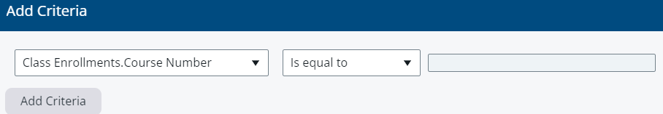

2. A list of students enrolled in the class will appear. Check the box next to the student record on the left side for those records to be edited, then click on **Selection** > **Subset** at the top of the page.

3. Then under **More**, select **Batch Edit.**

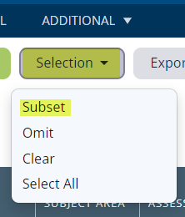 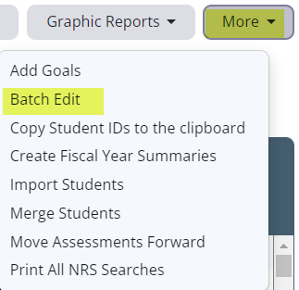

4. The following screen will appear. Check to make sure that the **Records to Be Updated** shows the number of students you intended. Then under **Non-NRS Fields** check the box next to **Student Keyword**, select your program from the dropdown menu and click **Save**. The **Student Keyword** will be added to all students you selected.

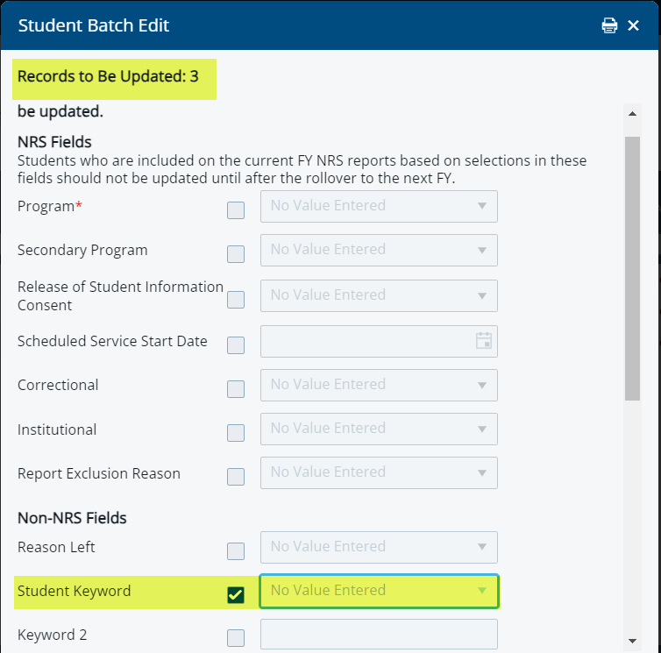

NOTE: Using the Student Keyword to track student enrollment by locality may not allow programs to assign more than one locality for each student.

## Rolling Forward Assessments

Remember from the August training that local provider staff is required to roll forward assessment scores for continuing students if they have valid tests from the previous year. This should be done before entering any post-tests. This can be done in one of two different ways:

* + Individually by student under the student Assessment tab, or
  + By rolling forward assessments for a group or batch of students.

If rolling forward as a batch, do so by class and in the same way as the Student Keyword (see above) but, under **More**, you would select **Move Assessments Forward**, instead of **Batch Edit**.

Review the procedures under [Move Forward Assessments](https://sites.google.com/literacypro.com/fyrolloverprocess/#h.o9b4kcw0hbj9) or at User News (under Profile Icon) > FY End/Rollover Preparation> Move Forward Assessments.

**Reminder**: If moving assessments forward manually and the student has two assessments in the same subject area (e.g., two Reading GOALS or two Life and Work Reading tests) within the move forward window, only the one generating the highest assessed level should be moved forward.

If moving forward assessments as a batch, the system will move forward all eligible tests. Example: Since CASAS Life and Work and CASAS STEPS are both still valid tests, both will be moved forward. You will want to check each student record and delete any unwanted assessments after the tests are moved forward.

## Technical Assistance

Questions related to the LACES database can be directed to the technical support staff using the technical support link provided in LACES, or at <https://laces.literacypro.com/laces/Content/usernews/laces/crmlng.htm>, by emailing technical support at [helpdesk@literacypro.com](mailto:helpdesk@literacypro.com), or by calling 1-888-714-9464. Technical support is answered in the following order: form, emails, calls, with urgent issues addressed based on priority. Help can be accessed by clicking the Help link provided on each page of the database or by using the provided Help link: <https://sites.google.com/a/literacypro.com/lps-support/lps-help-center>. Questions related to state or federal policy should be directed to [OAEL@doe.virginia.gov](mailto:OAEL@doe.virginia.gov).