# What a Day Jami Had!

**Grade Level:** Grade 8

**Subject(s):**

Primary: Reading

Integrated Activity: Pair with Lesson R-8.3 At What Time Should I Arrive?

**Reporting Category:**

Measurement and Geometry

**Lesson Summary and Connections:**

Students will use a story about a girl’s day and learn how to sequence events in a story. There are opportunities throughout the story to practice elapsed time as well.

**Lesson Components Links**

|  |  |  |  |
| --- | --- | --- | --- |
| **[VESOL(s)](#_VESOL(s):_1)**  **[Complexity Continuum](#_VESOL(s):_1)** | [**Functional Skills**](#_Student_Friendly_Outcome(s):) | [**Assistive Technology**](#_Assistive_Technology/AAC_(Augmentat) | **Materials** |
| **Vocabulary** | **Common Misconceptions** | [**Student-Friendly Outcome(s)**](#_Student-Friendly_Outcome(s):) | **Introductory Activity** |
| **Plan for Instruction** | **Differentiation** | **Reflection** | **Formative Assessment** |
| **Word Wall Cards** | **Supplemental Materials** | **Practice Items** | [**Integrated Activity**](#_Addendum(s):_Add_addendums) |

## 

## VESOL(s):

**M-8.3:** The student will tell time and measure elapsed time in minutes using analog and digital clocks including with context.

**Complexity Continuum:**

Times could be in one-minute increments in a.m. or p.m. and could include up to +/- 24 hours of elapsed time. Contexts will relate the time to an appropriate activity.

**R-8.6:** The student will identify an individual, **event**, or idea in a fiction passage that is read to the student or that the student reads.

**Complexity Continuum:**

The passage including an individual, event, or idea could range from three medium sentences with five to seven words to a paragraph with five to seven sentences.

## Functional Skill(s):

* Identify events happening around them.
* Tell a story using a sequence of events.

## Assistive Technology/AAC (Augmentative and Alternative Communication):

## Communication device or board

## Digital versions of sorting cards

## Materials:

* Word Wall Cards
* Book: What a Day Jami Had!
* Sequencing Events Cards
* Beginning, Middle, and End Organizer
* Formative Assessment
* Practice Items
* Use to integrate math into the story
  + Clock Number Lines
  + Open Number Line
  + Blank Clock
  + Interactive Clock
* Optional Materials
  + Page protector
  + Chart paper
  + Sticky notes
  + Online Interactive Clock
  + Judy clocks
* Additional books
  + [Morning Routine](https://tarheelreader.org/2020/04/30/morning-routine-6/)
  + [Going For a Run](https://tarheelreader.org/2020/04/03/going-for-a-run/)

## Vocabulary:

**Prior Knowledge**

|  |  |  |  |
| --- | --- | --- | --- |
| * time | * digital clock | * analog clock | * digital/analog clock |
| * daytime | * nighttime | * A.M. | * P.M. |
| * beginning | * middle | * end |  |

**Current Vocabulary**

|  |  |  |  |
| --- | --- | --- | --- |
| * event | * sequencing | * time on clock | * elapsed time 1 |
| * elapsed time 2 |  |  |  |

## Common Misconceptions:

* Students may struggle understanding that a story follows a sequence of events.
* Students may struggle keeping track of events as they progress through a story.

## Student-Friendly Outcome(s):

* I can tell what happened at the beginning of a story.
* I can tell what happened in the middle of a story.
* I can tell what happened at the end of a story.
* I can put events from a story in the order they happen.

## Introductory Activity:

* Use this funny [video](https://www.youtube.com/watch?v=j-6N3bLgYyQ) to introduce the vocabulary words “event” and “sequencing.”
  + In the video, the dad follows the instructions his children create to make a peanut butter and jelly sandwich (PBJ).
  + Stop the video after each attempt and discuss how the events (steps) could have been made clearer. Ask students if they think the dad completed steps in the correct sequence (order).
  + Make sure to hang the Word Wall Cards up in a central location and refer to them throughout the lesson.
  + This would be a good time to create an anchor chart for the lesson. An anchor chart is a tool that is used to support instruction throughout a unit. It is an “anchor” for the learning that is taking place. It should be created with your students (not prior to instruction), capture important content, and be displayed throughout the unit where students have access to it.
  + Next, make a PBJ in front of the class or show this [video](https://www.youtube.com/watch?v=4Z-RB81evsI) of someone making a PBJ. As you make the sandwich, tell student exactly what you are doing in each step.
    - *First, I pull out 2 pieces of bread, peanut butter, jelly, and a knife.*
    - *Then I spread the peanut butter on one slice of bread and jelly on the other slice of bread.*
    - *Lastly, I put the two pieces of bread together with the peanut butter side facing the jelly side.*
  + Ask students to summarize the first step – the beginning. Makes sure they understand that the beginning of a story contains the events that begin the story.
  + Next, ask students to summarize the second step – the middle. Make sure they understand that the middle contains the events that happen in the middle of the story.
  + Lastly, ask students to summarize the third and final step – the end. Make sure they understand the end contains all the events that happen at the end of the story.
  + Add the new vocabulary words to the other words and also include them on the anchor chart. Continue to refer to both resources throughout the lesson.

## Plan for Instruction:

* Hand each student a copy of the book, *What a Day Jami Had!*This part of the lesson can be done whole group or in small group instruction.
  + Ask students to predict what they think the story will be about by just reading the title.
    - Write down student thoughts on chart paper or the board. Come back to their predictions after the book has been read.
  + Project the book on a screen and encourage students to read along either in their version of the book or on the screen.
    - Read the story aloud, pausing to ask questions about what is happening up to that point. This will model how good readers ask questions as they read.
      * Example questions: “I wonder what will happen next?” “When will she get to…?”
    - Read the story again but this time pause and ask students what the event was in that section and highlight or circle the event.
      * Continue through the book having students explain to you which words to underline/circle. If students are capable, have them try to identify and highlight on their own.
  + Once the story has been read two times, hand students or pair of students the Sequencing Cards.
    - Tell students the cards are all the events that were highlighted in the story.
    - Have students place the cards in order as they happened in the story. Encourage them to refer back to the story as they complete the task.
    - Have a whole class discussion on the order and make sure all students have their cards in the correct order. Encourage students to explain their thinking and their sequence.
  + Now that the cards are in order, hand students the Beginning, Middle, & End Organizer.
    - Have students place the cards in the section they feel is appropriate for the event.
    - As students are completing the organizer, ask questions like, “why did you put those cards in the beginning section?", “Would it make sense to move this card to a different section of the organizer? Why or why not?”
    - Once you have checked the cards are in the correct place on the organizer, have students write the definition, in their own words, for each word in the organizer. This will act part of the formative assessment and reflection for the lesson.
      * Those who are able, can glue the cards in place, those who cannot, hand them a Completed organizer. The definition is blank, but you could also fill that in for those who can not do it on their own.
  + In the Materials List are several books that can be used to enhance instruction. Use these or other reading materials to reinforce student understanding.
  + To assess student understanding, have students read (or be read to) and answer questions for one or both of the stories in the Formative Assessment. (The second story is the easier of the two.)

## Differentiation:

* See ways to differentiate suggested throughout the lesson.
* Use fewer cards in the sequencing activity for students who need shortened assignments or struggle with the amount of cards.
* Have students create their own story and describe the events and their sequence.

## Reflection:

* Ask questions like, “Why did you put those cards in the beginning section?" or “Would it make sense to move this card to a different section of the organizer? Why or why not?”
* Ask students, “What is an event? How do you keep track of what events happen at the beginning of a story, in the middle, and at the end?”

## Formative Assessment:

* Take anecdotal notes as the students are answering your questions. Denote students’ progress toward the student-friendly outcomes stated.
* Use the Beginning, Middle, and End Organizer to identify students who have achieved the outcomes or may need more support.

**Formative Assessment**

Directions: Use one or both of the following stories to measure if students can apply their learning to new stories.

**Story 1**

|  |  |
| --- | --- |
| Brandon went to the store to buy some bread, milk, and a carton of eggs. He walked into the store, got a cart, and walked through the store to find bread. Brandon placed the bread in his cart and went to look for milk. He found milk in the dairy section and placed it in his cart. Brandon found the carton of eggs a few steps away and placed it in the cart. Then he headed to the cash register. The person at the cash register rang up his order, placed all items in a bag, and told him his total was $13.88. Brandon paid for the items, picked up the bag, and walked out of the store. | A picture of a supermarket and shopping cart. |

1. What happened at the beginning of the story? Brandon____

A paid for the items B bought milk C walked into the store

1. What was the first item Brandon bought?

A bread B bag C eggs

1. At the end of the story, Brandon _______.

A walked into the store

B walked out of the store

C walked through the store

Story 2

|  |  |
| --- | --- |
| George the frog loved to sit in the flower pot in April’s yard. He would sit and watch the bees buzz around the flowers. One day, April came into the yard with her dog. The dog came over to George’s pot and started sniffing. George stayed really still so the dog would not see him. The dog got bored and walked away. George was happy the dog did not see him and enjoyed the rest of the day. | A picture of three frogs in a pot with flowers. |

* 1. Did the dog walk away at the beginning, middle or end of the story?

A beginning B middle C end

1. Where did George sit at the beginning of the story?

A in a pot B in a pond C on the ground

1. What happened in the middle of the story?

A George was happy B dog sniffed the pot C April sang a song

## Integrated Activity:

* This lesson should be paired with Lesson R-8.3 At What Time Should I Arrive?
* There are elapsed time questions located in the story, What a Day Jami Had!.
  + If this lesson is completed prior to the lesson on elapsed time, save those questions until you complete that lesson.
  + If this lesson is completed after the lesson on elapsed time, use them as a review of that lesson.

## Word Wall Cards:

Clock

time

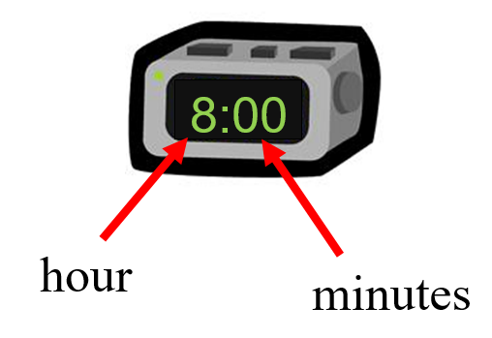

digital

Clock

time

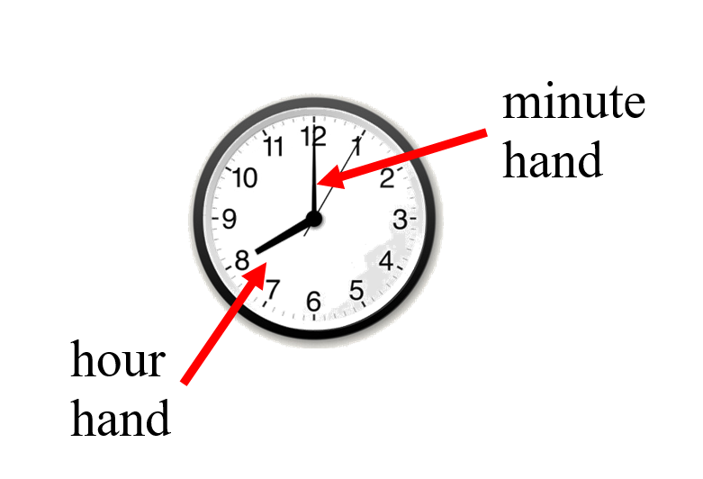

analog

Clock

time

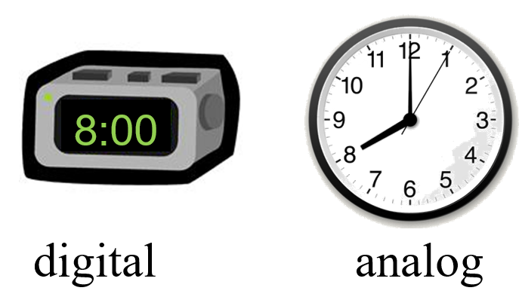

A.M.

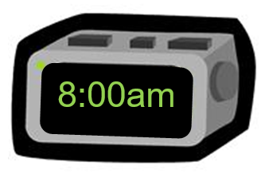

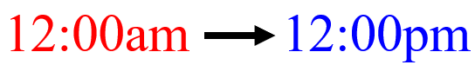

midnight to noon

P.M.

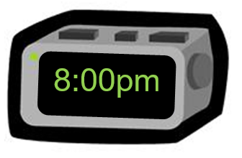

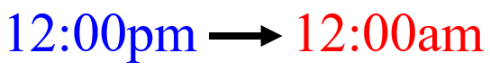noon to midnight

Daytime

|  |  |
| --- | --- |
| Silhouette Sun | Sunrise Field |
| Xiamen City | drawn cartoon farm with a red tractor |

Nighttime

|  |  |
| --- | --- |
| An image of a shop at night with the moon out. | time square new york city night view |
| abandoned house during a thunderstorm at night | night sky moon forest |

Clock

minutes, one-half hour,

one hour



30 minutes = one-half hour

60 minutes = 1 hour

24 hours = 1 day

Elapsed Time

amount of time that has passed between two given times

The movie starts at 2:00 p.m. and ends at 5:00 p.m.

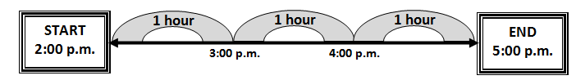

The movie is three hours long.

Elapsed Time

amount of time that has passed between two given times

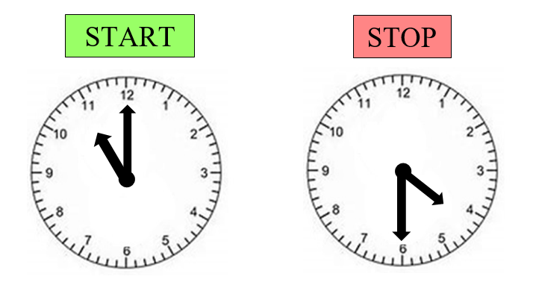

Sequencing

putting events in order

beginning

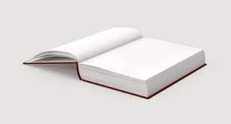

middle

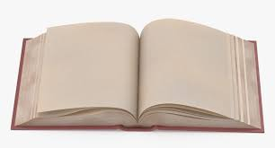

End

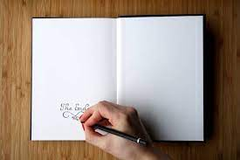

Beginning

how a story starts



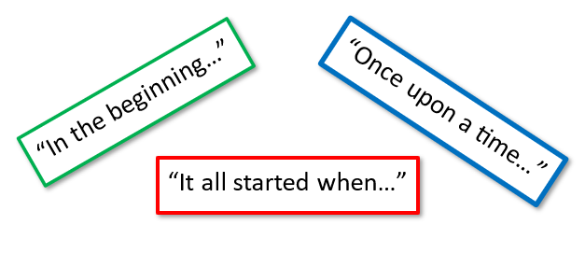

Middle

where the story happens



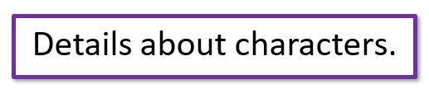

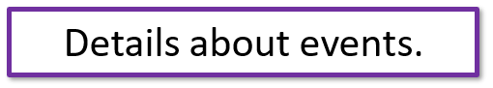

End

how the story closes



They lived happily ever after.
He won the race and celebrated.
In the end, they became friends.

Event

Something that happens in a story

At top, a picture of people running in a race,
At right, a picture of a rocket leaving earth with Going to outer space written underneath.
At bottom two girls playing at the playground.

## Supplemental Materials:

Clock Number LinesA clock number line starting at 12 am midnight, going to noon 12 pm and ending at midnight 12 am
AM and PM with arrows below the number line.

A clock number line starting at 12 am midnight, going to noon 12 pm and ending at midnight 12 am
AM and PM with arrows below the number line.

A clock number line starting at 12 am midnight, going to noon 12 pm and ending at midnight 12 am
AM and PM with arrows below the number line.

Open Number Lines

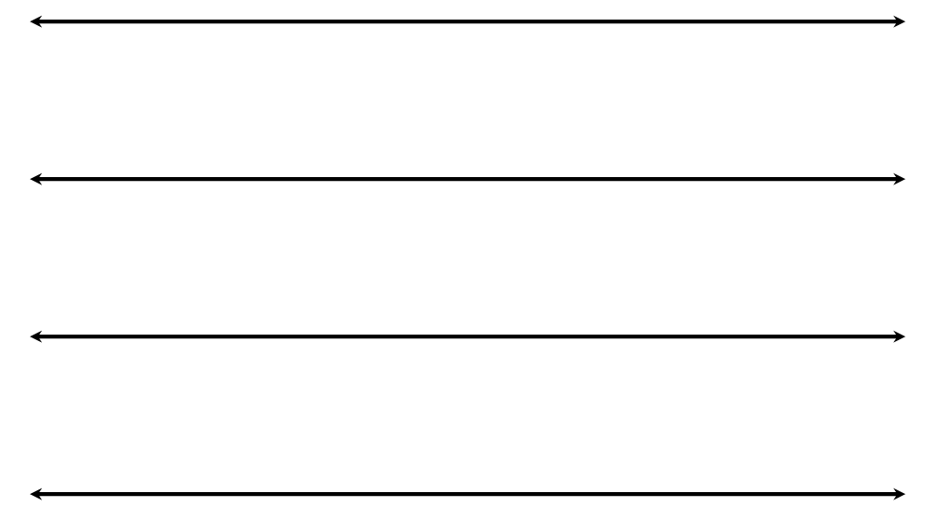

Analog Clock

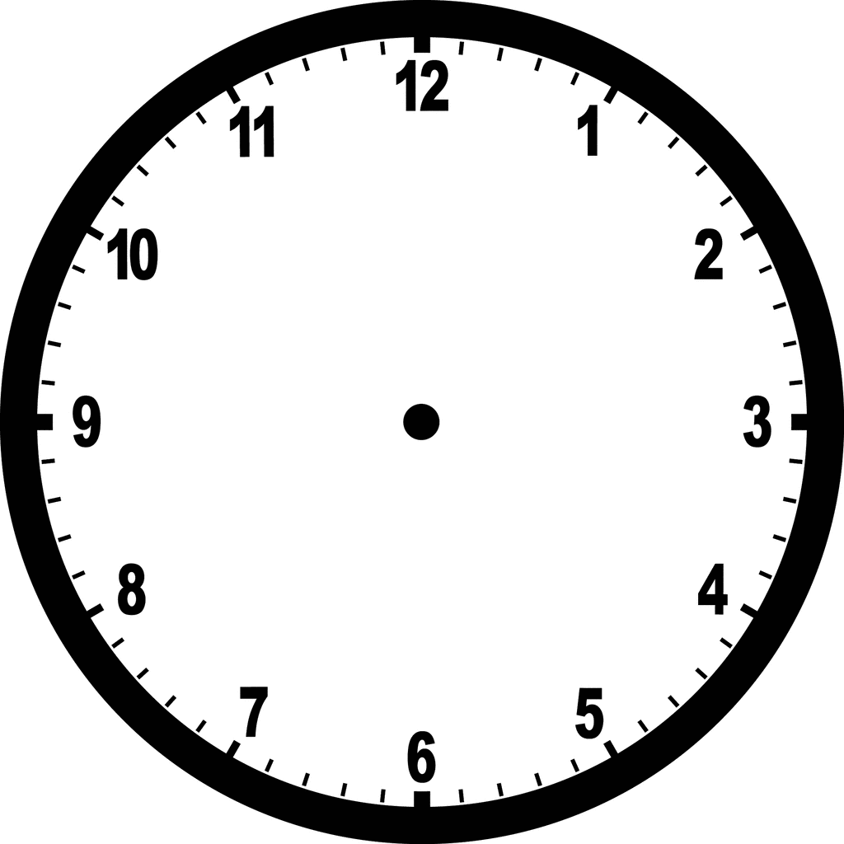

Interactive Clock.
Use a brad or other fastener to attach the hour and minute hand to the center point of the clock.
A small and large arrow.

What a Day Jami Had!

By Michele Giglio

Jami woke up at 7:05. She could smell breakfast cooking.

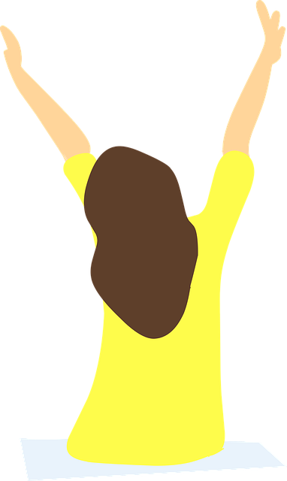

Her mom made eggs and bacon.

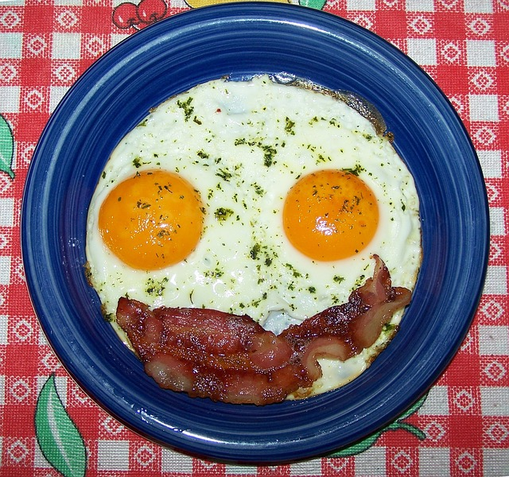

After breakfast, Jami walked her dog. It was 7:36 a.m. and chilly.

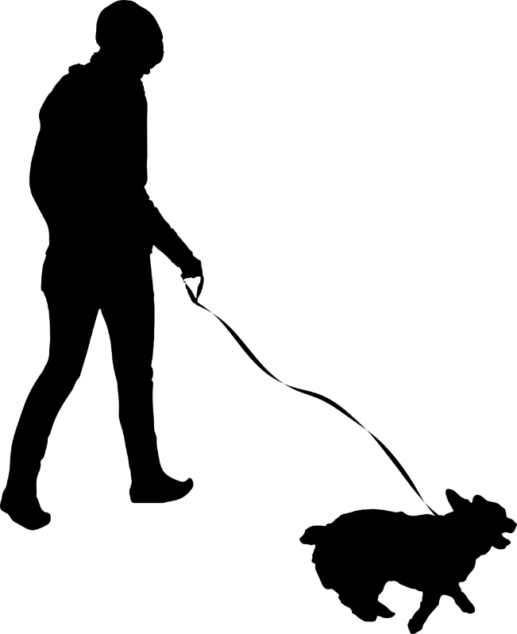

At 8:15, Jami sat with her mom and waited for the bus. They talked about their morning.

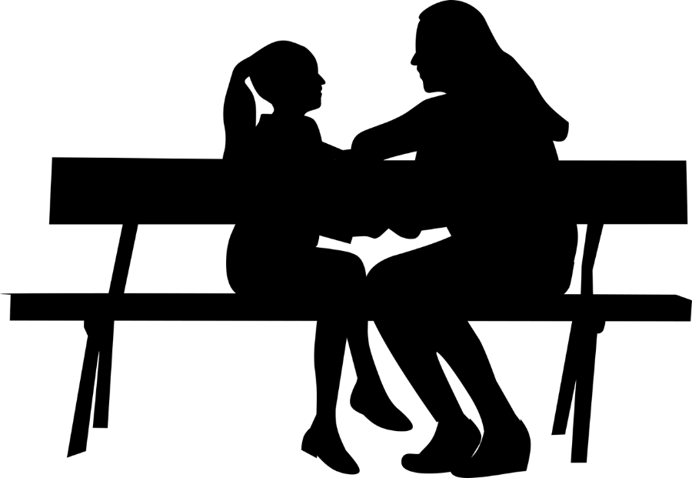

If the bus came at 8:25 a.m., how much time did Jamie and her mom have to talk?

Jami had fun at school. She read books and learned about time in math.

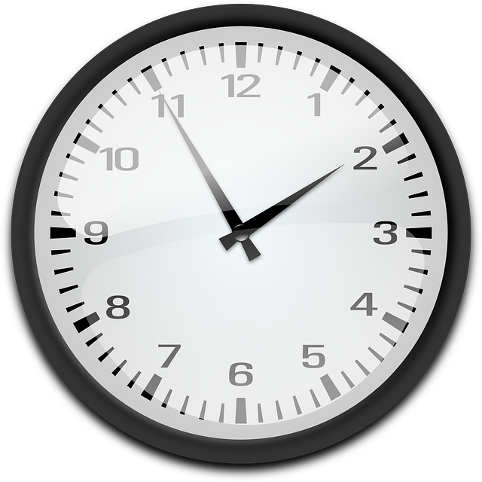

School was over and Jami got on the bus. It was 3:38 p.m. She hoped the bus would hurry because her favorite TV show came on at 4:00 p.m.



How much time did she have until her favorite TV show came on?

At 6:45 p.m., Jami and her family went for a walk to the beach. Wow. Jami has a lot of brothers and sisters.

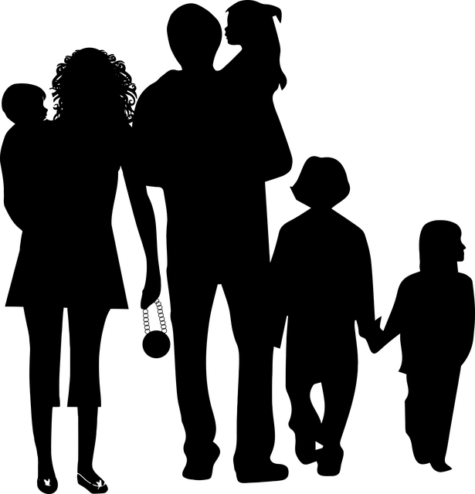

At 7:15 p.m. Jami and her family got to the beach. She and her sister ran and jumped. They were excited to be at the beach. They love watching the sun set.



How long did it take Jami and her family to walk to the beach?

When the sun set, Jami and her family walked home.

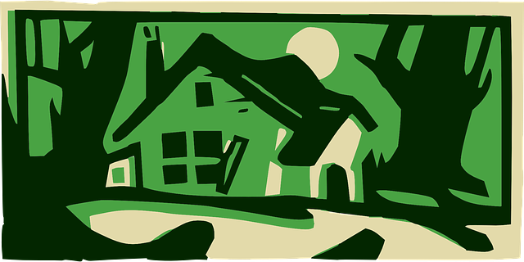

Jami brushed her teeth and got into bed at 9:15. It was a great day!

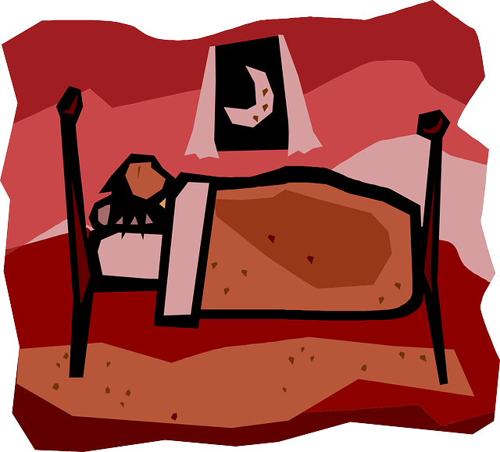

Sequencing Events Cards

Create a set of cards for each student or pair of students. Make sure to shuffle the cards so they are not in order.

|  |  |  |
| --- | --- | --- |
| Jami woke up.  A picture of a person with arms up in the air. | Jami walked her dog.  A picture of a person walking a dog. | Jami and her mom waited for the bus.  A picture of two people sitting on a bench. |
| Jami rode the bus to school.  A picture of a bus. | Jami read books and learned about math.  Picture of a book and a clock. | Jami left school and rode the bus home.  A picture of a school and bus. |
| Jami and her family walked to the beach.  A picture of a family walking together. | Jami played on the beach.  A picture of two people jumping at the beach. | Jamie went to bed.  A picture of a person in bed. |

Beginning, Middle, and End Organizer

Using the story, put the Sequencing Events Cards in order of when they happened in the story. Be able to explain how you know they are in the correct order.

Place the cards in the Beginning, Middle, and End Organizer so they represent what happened in the beginning of the story, middle of the story, and the end of the story.

|  |  |  |
| --- | --- | --- |
| Beginning | Middle | End |
| Definition: | Definition: | Definition: |

Completed Beginning, Middle & End Organizer

Using the story, put the Sequencing Cards in order of how they happened in the story. Be able to explain how you know they are in the correct order.

Place the cards in the Beginning, Middle, & End Organizer so they represent what happened in the beginning of the story, middle of the story, and the end of the story.

|  |  |  |
| --- | --- | --- |
| Beginning | Middle | End |
| Definition:  Jamie woke up. A picture of a person with arms up in the air.  Jami walked her dog. A picture of a person walking a dog.  Jamie and her mom waited for the bus. A picture of two people sitting on a bench. | Definition:  Jami rode the bus to school. A picture of a bus.  Jami read books and learned about math. Picture of a book and a clock.  Jamie left school and rode the bus home. A picture of a school and bus. | Definition:  Jami and her family walked to the beach. A picture of a family walking together.  Jami played on the beach. Two people jumping at the beach.  Jamie went to bed. A picture of a person in bed. |

**Practice Items**

**Denise started her day by getting up and eating breakfast. The school bus then picked her up and took her to school. She liked going to her different classes at school. When School was out, she rode the bus home. Once home, she ate dinner with her family.
What was the last meal Denise ate?
A lunch
B dinner
C snacks**