# At What Time Should I Arrive?

**Grade Level:** Grade 8

**Subject(s):**

Primary: Math (Lesson can be paired with lesson M-8.3 What Time is it?)

Integrated Activity: Reading – Pair with lesson R-8.6 What a Day Jami Had!

**Reporting Category:**

Measurement and Geometry

**Lesson Summary and Connections:**

Students will use number lines and clocks to calculate elapsed time. Students will also practice how to sequence events in a story.

**Lesson Components Links**

|  |  |  |  |
| --- | --- | --- | --- |
| **[VESOL(s)](#_VESOL(s):)**  **[Complexity Continuum](#_VESOL(s):)** | [**Functional Skills**](#_Functional_Skill(s):) | [**Assistive Technology**](#_Assistive_Technology/ACC_(Augmentat) | **Materials** |
| **Vocabulary** | **Common Misconceptions** | [**Student-Friendly Outcome(s)**](#_Student_Friendly_Outcome(s):_1) | **Introductory Activity** |
| **Plan for Instruction** | **Differentiation** | **Reflection** | **Formative Assessment** |
| **Word Wall Cards** | **Supplemental Materials** | **Practice Items** | **Integrated Activity** |

## VESOL(s):

**M-8.3:** The student will tell time and measure elapsed time in minutes using analog and digital clocks including with context.

**Complexity Continuum:**

Times could be in one-minute increments in a.m. or p.m. and could include up to +/- 24 hours of elapsed time. Contexts will relate the time to an appropriate activity.

## Functional Skill(s):

* Learn how to calculate how long it will take to accomplish a task.
* Determine if there is enough time to finish an assignment or task.
* Identify events happening around the student.
* Tell a story using a sequence of events.

## Assistive Technology/AAC (Augmentative and Alternative Communication):

## Communication devices appropriate for the student programmed with numbers for counting and responding

## Enlarge materials for students with vision impairments

## Alternative methods of responses

## [Digital/Analog Interactive clock](https://toytheater.com/clock/)

## Materials:

* Introduction Cards
* Word Wall Cards
* Clock Number Lines
* Open Number Line
* Blank Clock
* Interactive Clock
* Formative Assessment
* Optional Materials
  + Page protector
  + Chart paper
  + Sticky notes
  + Online Interactive Clock

## Vocabulary:

**Prior Knowledge**

|  |  |  |  |
| --- | --- | --- | --- |
| * time | * digital clock | * analog clock | * digital/analog clock |
| * daytime | * nighttime | * a.m. | * p.m. |
| * noon | * midnight |  |  |

**Current Vocabulary**

|  |  |  |  |
| --- | --- | --- | --- |
| * time on clock | * elapsed time 1 | * elapsed time 2 |  |
|  |  |  |  |

## Common Misconceptions:

* Since time does not use the base ten system, students may struggle understanding that one day is 24 hours and one hour is 60 minutes. They may try to use base ten strategies to determine total hours and minutes.
* Students may include the hour/minute they are starting from when counting up instead of starting with the next hour/minute.
* Students may struggle understanding each number on the clock represents a multiple of 5.
* Students may struggle keeping track of elapsed time in minutes on a clock because the minutes are not numbered.
* Students may have difficulty understanding the difference between a.m. and p.m. and how these relate to noon and midnight.

## Student-Friendly Outcome(s):

* I will be able to tell time to the minute.
* I will be able to tell the difference between a.m. and p.m.
* I will be able to find how much time has gone by between activities.
* I will be able to find the time an activity starts.

## Introductory Activity:

* With students, create a list of activities you do on a typical school day (e.g., wake up, eat lunch). Let students lead the conversation while you write down the activities they mention on chart paper or the board. Do not put the activities in order of when they would occur.
* After the students have finished listing their activities, ask them, “How would you put these activities in order?” or “Which activity should go first?” Encourage students to explain their thinking.
* Tell students, “We will come back to this list during the lesson.”
* Next hand each student a set of Introductory Cards. (If your students are able, they could work with a partner.) In this activity, students will only be using the ***Event*** cards, so either you or the student should pull out the ***Time***cards and the ***Elapsed-Time*** cards and put them to the side. (They will use these later in the lesson.)
* Have students sequence the Event cards in the order they think they belong. Circulate the room and encourage students to talk about how they are sorting and ordering and why they think they are correct.
* Once most the students are finished sequencing the cards, have a few students share their order. (Some of the activities after school may be in a different order and still be correct.)

## Plan for Instruction:

* The majority of the vocabulary for this lesson has been taught in previous years. Use the Word Wall Cards as a starting point for your lesson. Ask students what they remember about each one and quickly jot down any additional ideas on a sticky-note on the card. Display the Word Wall Cards throughout the lesson so students can refer back to them while learning the concept.

**Review**

* Students have been working with elapsed time since Grade 5.
  + 5th grade uses hour and half hour,
  + 6th grade includes 15 minutes and
  + 7th grade includes 5 minutes.
* Reading time: Use a digital [interactive clock](https://www.visnos.com/demos/clock) or create an Interactive Clock and have students practice telling time to the hour, half hour, 15-minute and 5-minute intervals. Once you feel students have reviewed enough you can start the elapsed time review.
* Elapsed time: Next, hand out a couple of copies of the Clock Number Lines handout to each student. (If you have a laminator or page protector and markers, you could give each student one.) Students will use these Clock Number Lines to review previous content.
* Use the following examples to start the review lesson. Feel free to add additional examples. Use the images to help you model how to use the Clock Number Line.
  + Hour review
    - You wake up at 6:00 a.m. and school starts at 8:00 a.m. How much time do you have to get ready for school?

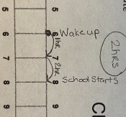

* + - You get off the bus at 3:00 p.m. and go to sleep at 9:00 p.m. How much time do you have to do your homework, eat, and play before bed?

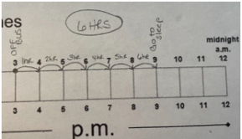

* + - Your mom tells you at 7:00 p.m. you have one more hour to play your game. At what time do you have to stop playing your game?

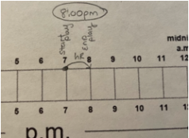

* + - You go to sleep at 9:00 p.m. and sleep for 9 hours. At what time do you wake up?

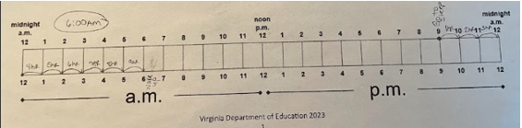

* + Hour and 30-minute review
    - You are at school, and it is 8:30 a.m. Lunch starts at 11:00 a.m. How much time until lunch?

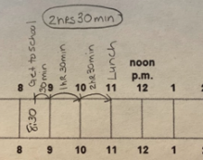

* + - Your Mom says you can play at your friend’s house for 1 ½ hours. If you leave your house at 4:00 p.m., at what time do you have to be back home?

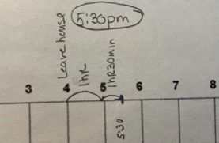

* + - You get to stay up late. You go to sleep at 10:30 p.m. and wake up at 9:30 a.m. How many hours did you sleep altogether?

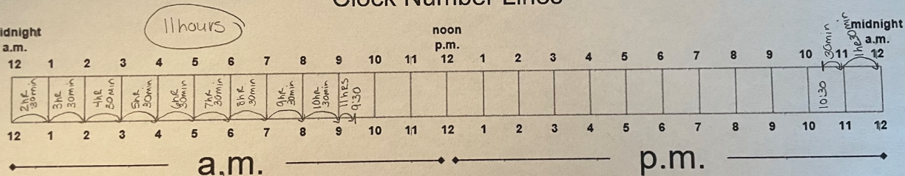

You can continue to use hour and ½-hour type questions until you feel the majority of your students are able to use the organizer and/or their own strategies to answer the questions.

* + 15-minute review
    - These Clock Number Lines are a little small, so the next part of the review lesson, we will transition to an Open Number Line. Some students may prefer to continue to use the clock number line and that is fine. As with the first part of the lesson, hand each student several copies or one laminated copy of the Open Number Lines.
      1. You wake up at 8:45 a.m. You will leave for your soccer game at 10:00 a.m. How much time do you have between waking up and leaving for the soccer game?
      2. Your soccer game ends at 11:30 a.m. It takes 45 minutes to drive home. What time will it be when you arrive home?
      3. Tonight is your school’s skate night. It starts at 7:00 p.m. You finish eating lunch at 2:15 p.m. How much time do you have to wait until skate night starts?
      4. You get home from skating at 9:00 p.m. You decide to get your reading homework done and want to read for 1 hour 15 minutes. What time will it be when you are finished reading?

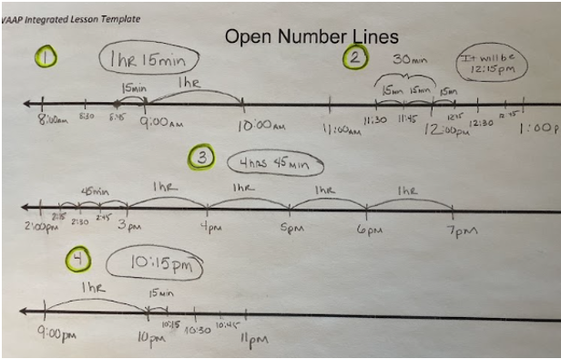

You can continue to use 15-minute type questions until you feel most your students are able to use the organizer and/or their own strategies to answer the questions.

* + 5-minute review
    - You can continue to use the Clock Number line, Open Number Line, or introduce the Analog Clock.

1. You hear a loud noise that wakes you up at 3:35 a.m. You fall back to sleep at 4:00 a.m. How long were you awake?
2. It is 11:55 a.m. You are watching a show on TV. Your brother wants to watch a different show that comes on at 1:00 p.m. How much longer until your brother’s show comes on?
3. Your friend comes over at 3:25 p.m. and says she can stay for 2 hours 15 minutes. At what time will your friend have to leave?

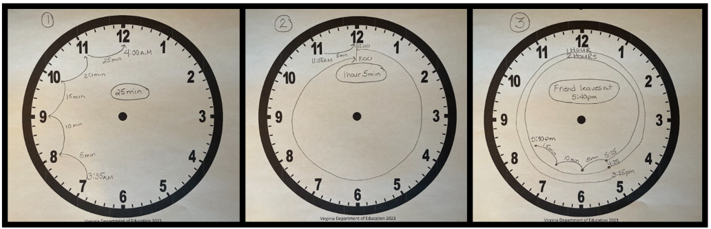

**Part I: (1-minute)**

* Using the open number lines or analog clock, introduce the lesson with this situation:

*Michael looks at the clock. It is 5:51 a.m. Football practice starts at 6:30 a.m. How much time does he have before football practice starts?*

* + There are many ways students can use the number lines and analog clock handouts. Introduce the way that is most comfortable for you and then get students to explore other ways to find the elapsed time for this situation.
    - Possible strategies: (This is not an exhaustive list – Challenge students to create their own strategies.)
      * Count by 1’s – Start at 5:51 and count each tick mark until you reach 6:30.
      * Count by 1’s and 30 - Start at 5:51 and count by 1’s until you get to 6:00 (9 minutes) then add 30 minutes (modeled on the open number line below). **OR** start at 6:30 and count backwards by 30 to 6:00 then add on by one until you get to 5:51.
      * Count by 1’s and 10’s – Start at 5:51 and count by 1’s until you get to the 6:00 (9 minutes) then skip count by 10’s (modeled on the analog clock image below) **OR** start at 6:30 and count backwards by 10 to 6:00 then add on by one until you get to 5:51.
      * Count by 1’s and 5’s – Start at 5:51 and count by 1’s until you get to the 6:00 then skip count by 5’s (This will be a very challenging strategy) **OR** start at 6:30 and count by 5’s until you get to 5:55 and then count by one to 5:51.

**Diagram of an open number line for the example for one minutes.
Diagram of an open clock for the example for one minute.**

* Once students have tried several strategies, have them practice the strategies with the following scenarios. As much as possible, have students explain their thinking and/or their strategies.
  1. Your favorite TV show comes on at 8:00 p.m. If it is 7:18 p.m. now, how many minutes until your favorite TV show comes on?
  2. Mandeep was running a race. He started running at 3:30. It took him 34 minutes to finish the race. What time was it when he finished the race?
  3. Frank and Marta wondered who could finish their homework first. Frank started at 4:45 p.m. and ended at 5:12 p.m. Marta started her homework at 4:24 p.m. and finished at 4:50 p.m. Who finished first? How do you know?
  4. You get 28 minutes to eat your lunch at school. If lunch ends at 12:02 p.m., at what time do you start eating lunch?
  5. Sam started playing video games at 7:22 p.m. He stopped playing video games at 9:22 p.m. How long did Sam play video games?
  + Continue giving students scenarios until you feel they are comfortable.
  + To increase the difficulty:
    - Have the elapsed time intervals go beyond a couple of hours
    - Have the start and stop times on a hash mark (e.g., 7:22 a.m. to 9:34 a.m.)
    - Have the start and stop times before and after either noon or midnight (e.g., 8:06 a.m. to 3:56 p.m.)
    - Have the start and stop times extend over a 12-hour period or a day.
  + To decrease the difficulty:
    - Use an elapsed time that is less than 10 minutes (e.g.,11:00 a.m. to 11:08 or 6:32 p.m. to 6:38 p.m.)
    - Have the start time on the hour or half-hour and the end time less than 20 minutes away (e.g., 7:00 a.m. to 7:14 a.m. or 2:30 p.m. to 2:47 p.m.)

**Part II: Practice**

* Hand students the Introduction Cards, Clock Number Lines, Open Number Line, Blank Clock and/or Interactive Clock
  + Have students sort the cards into three piles: Event, Start Time, and Elapsed Time.
  + In the introductory activity students sequenced the Event cards. You may display the order on the board or see if they can order them on their own.
  + Working with a partner or in small groups, students should use an organizer of their choice and match the time and elapsed time with each event.
  + As students are completing the activity, ask students questions such as, “What strategy did you use to find the amount of time between those two activities?” “Is there another way you could have found the elapsed time?” “How does your strategy compare to _____’s strategy?”
  + Once students have completed the sequencing activity, have a class discussion on what they learned and how they can apply the strategies used in their daily lives.

## Differentiation:

* Ways to differentiate are pointed out throughout the lesson with the different organizers and questioning examples.
* All organizers and cards can be enlarged for students who need that accommodation.
* For students who struggle, keep the elapsed times to shorter periods of time.
* For those students who are excelling with the concept, extend the time across a.m. and p.m.

## Reflection:

Have students explain what strategy they use most often when finding elapsed time. Have them explain the strategy. If students struggle to tell a strategy or with the explanation of their strategy, give them a scenario like “Our reading lesson was over at 8:20. The teacher gives us a 6-minute break before she started the math lesson. At what time will math lesson start?” Use simpler times if the student continues to struggle.

## Formative Assessment:

* Throughout the lesson, keep track of students’ progress as they learn how to use the organizers.
* The Introduction Card ordering activity can also be used as a Formative Assessment along with the Formative Assessment Handout.

## Integrated Activity:

* This lesson can be paired with lesson R-8.6 What a Day Jami Had! and lesson M-8.3 What Time is it?

**Notes:**

* This lesson should be broken up over two to three days depending on the ability levels in your class.

**Formative Assessment**

Directions: Give students an elapsed time organizer of their choice and have them answer the following questions.

|  |  |
| --- | --- |
| 1. John started soccer practice at 2:34 P.M.   A picture of an clock showing the time of 2:34 PM  John got a water break 30 minutes after practice started.  At what time did John’s water break start?  **A** 2:37 P.M.  **B** 3:34 P.M **C** 3:04 P.M. | 1. Sally started watching a movie at 1:55 P.M.   A picture of a clock showing 1:55 PM  The movie was 2 hours 10 minutes long.  At what time did the movie end?  **A** 2:05 P.M. **B** 4:05 P.M. **C** 4:55 P.M. |
| 1. Marcus was outside hiking in the woods. He saw the time on his watch was 4:20 P.M.   A picture of a watch showing 4:20.  He had to be home for dinner by 4:59.  How much time was left before he had to be home?  **A** 20 minutes **B** 39 minutes **C** 59 minutes | 1. Chin woke up and read the clock. It was 6:18 A.M.   A picture of a clock showing 6:18.  If Chin had to get on the bus at 7:08 A.M., how much time did she have to get ready?  **A** 60 minutes **B** 50 minutes **C** 10 minutes |

**Word Wall Cards:**

Clock

time

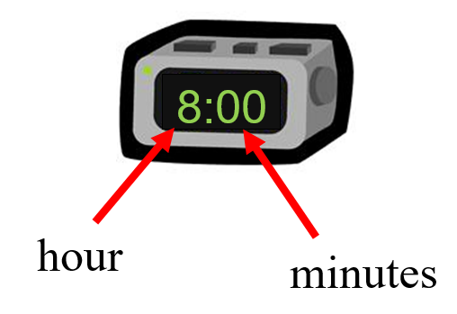

digital

Clock

time

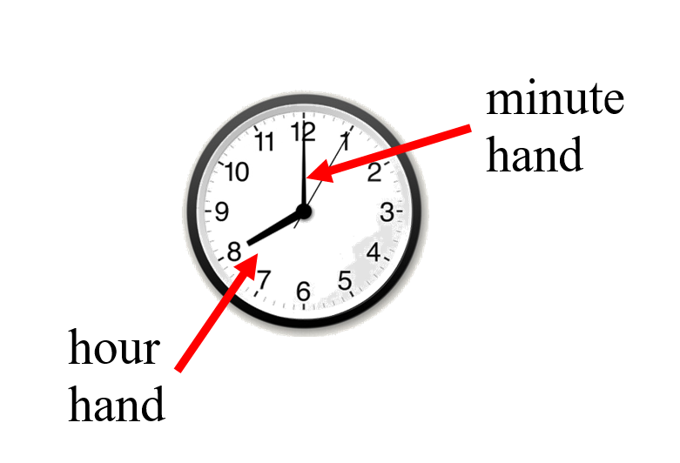

analog

Clock

time

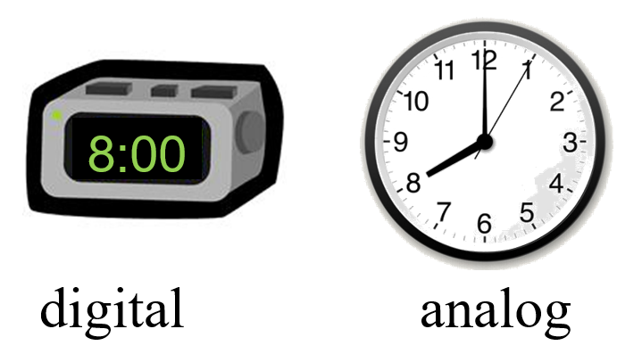

Midnight

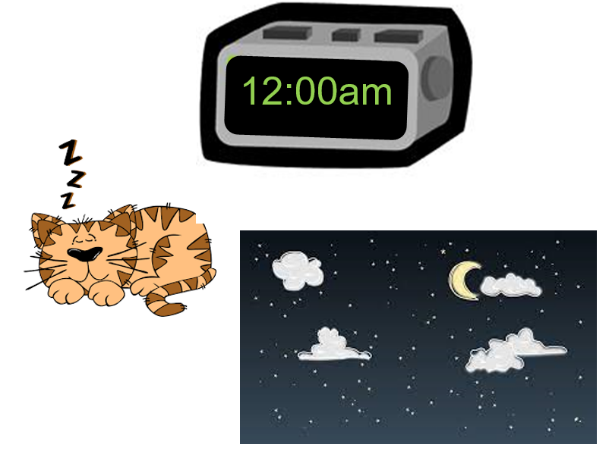

Noon

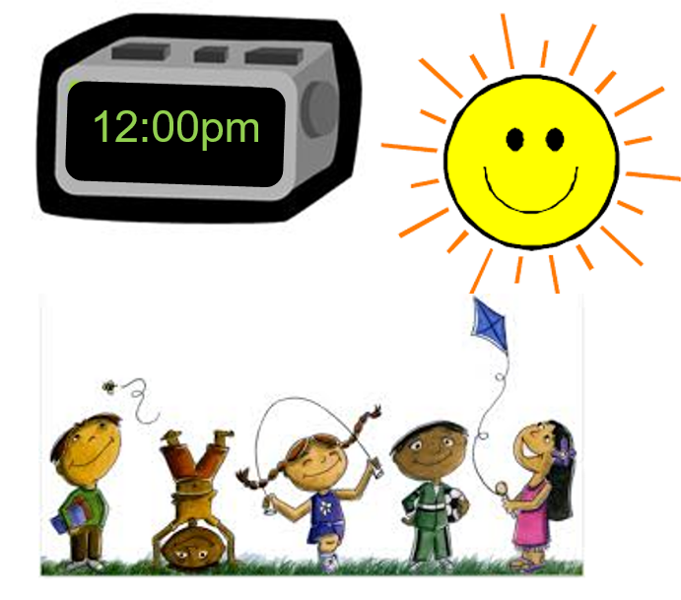

A.M.

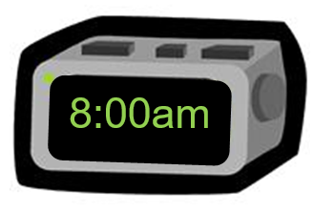

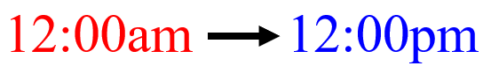midnight to noon

P.M.

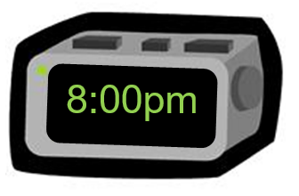

noon to midnight

Daytime

|  |  |
| --- | --- |
| Silhouette Sun | Sunrise Field |
| Xiamen City | drawn cartoon farm with a red tractor |

Nighttime

|  |  |
| --- | --- |
| An image of a shop at night with the moon out. | time square new york city night view |
| abandoned house during a thunderstorm at night | night sky moon forest |

Clock

minutes, one-half hour,

one hour

30 minutes = one-half hour

60 minutes = 1 hour

24 hours = 1 day

Elapsed Time

amount of time that has passed between two given times

The movie starts at 2:00 p.m. and ends at 5:00 p.m.

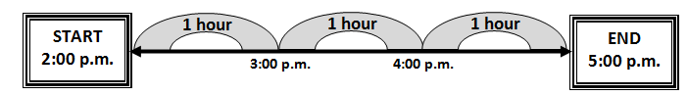

The movie is three hours long.

Elapsed Time

amount of time that has passed between two given times

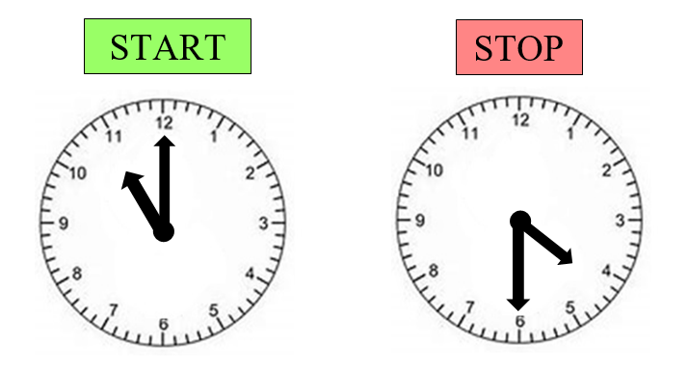

## Supplemental Materials:

Introduction Activity - Cut out cards and place in baggies. Students will use the cards to sort first by activity then by what time they think each activity starts. Use the Elapsed-Time cards as a formative assessment after the lesson.

|  |  |  |
| --- | --- | --- |
| **Event** | **Start Time** | **Elapsed Time** |
| Wake Up | 6:00 a.m. |  |
| Eat Breakfast | 6:25 a.m. | 25 minutes |
| Get on Bus to Go to School | 7:05 a.m. | 40 minutes |
| Eat Lunch | 11:37 a.m. | 4 hours 32 minutes |
| Get on Bus to Go Home | 3:05 p.m. | 3 hours 28 minutes |
| Eat a Snack | 3:35 p.m. | 30 minutes |
| Do Homework | 4:10 p.m. | 35 minutes |
| Play Video Games | 5:02 p.m. | 48 minutes |
| Eat Dinner | 6:35 p.m. | 1 hour 33 minutes |
| Go to Bed | 9:30 p.m. | 2 hours 55 minutes |

Clock Number LinesDouble number line for time. Starting at 12 AM and going to 12PM. Noon is marked in the middle.
An arrow at the bottom shows AM on the left and PM on the right.

Double number line for time. Starting at 12 AM and going to 12PM. Noon is marked in the middle.
An arrow at the bottom shows AM on the left and PM on the right.

Double number line for time. Starting at 12 AM and going to 12PM. Noon is marked in the middle.
An arrow at the bottom shows AM on the left and PM on the right.

Open Number Lines

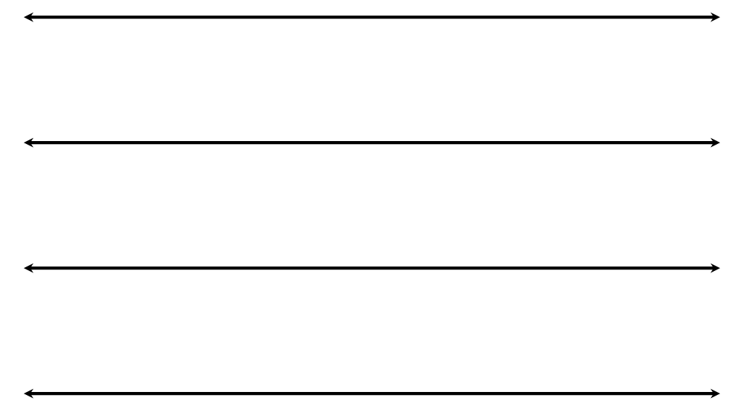

Analog Clock

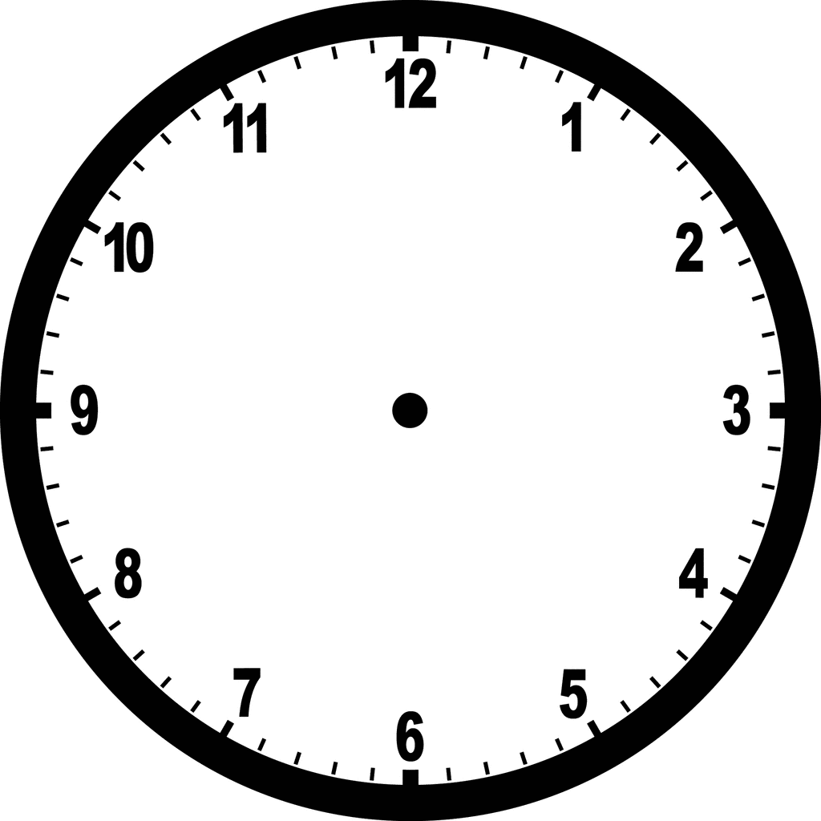

Interactive Clock.
Use a brad or other fastener to attach the hour and minute hand to the center point of the clock.
a small and large arrow.

**Practice Items**

**Examiner’s Text:**

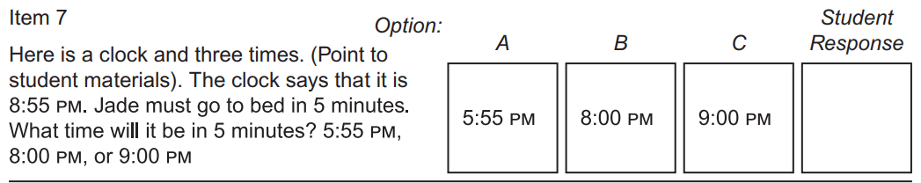

**Student Question:**

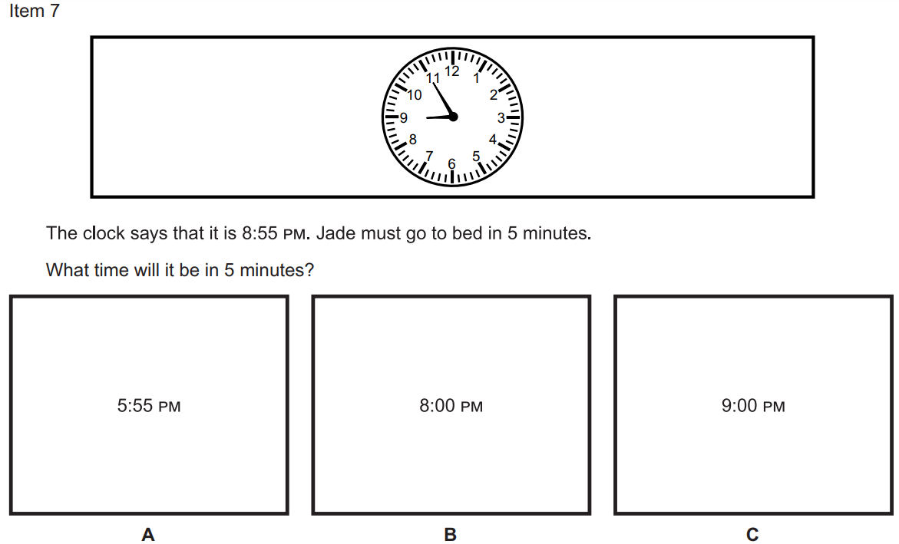

Grade 7 Item:

Examiner’s Text

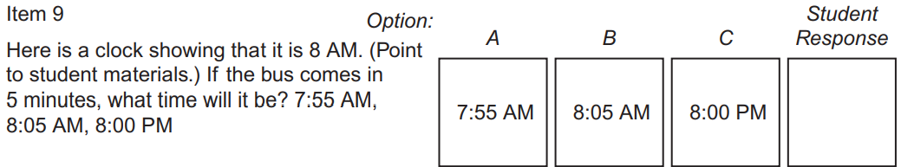

Student Question:

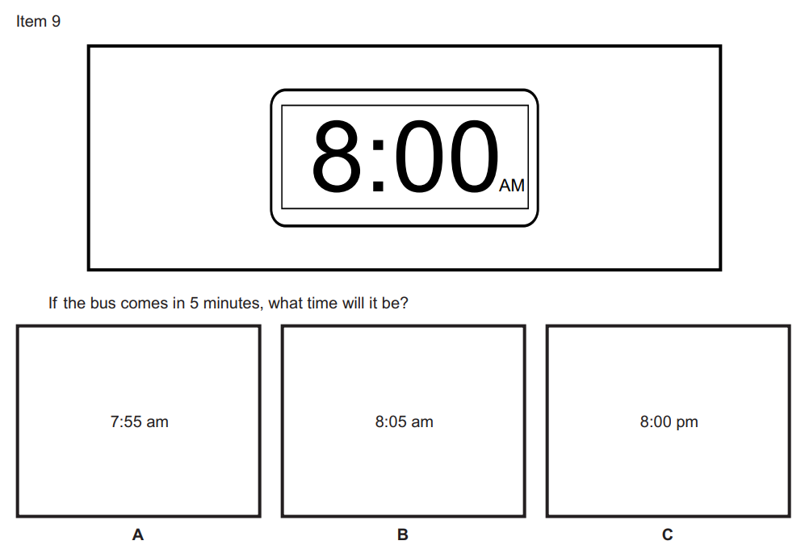

**Grade 6 Item:**

**Examiner’s Text:**

**Here are three clocks for you to read. (Point to student materials,) Which clock shows 8:15 in the morning? (Do not read answer choices.) A, B, or C

A 8:15 am, B 8:00 pm, 8:15 pm.**

**Student Question:**

Here are three clocks for you to read. (Point to student materials,) Which clock shows 8:15 in the morning? (Do not read answer choices.) A, B, or C

A 8:15 am, B 8:00 pm, 8:15 pm.