**I Will Survive**

**Grade Level:** 5

**Subject(s):** Science

Primary: Science

Integrated Activity: Reading

**Reporting Category:**

Living Systems and Ecosystems Interactions

**Lesson Summary and Connections:**

Students will learn that the distinct characteristics of plants and animals play a key role in their survival.

**Lesson Components Links**

|  |  |  |  |
| --- | --- | --- | --- |
| **[VESOL(s)](#_VESOL(s):)**  **[Complexity Continuum](#_VESOL(s):)** | [**Functional Skills**](#_Functional_Skill(s):) | [**Assistive Technology**](#_Assistive_Technology/ACC_(Augmentat) | **Materials** |
| **Vocabulary** | **Common Misconceptions** | [**Student-Friendly Outcome(s)**](#_Student_Friendly_Outcome(s):_1) | **Introductory Activity** |
| **Plan for Instruction** | **Differentiation** | **Reflection** | **Formative Assessment** |
| **Word Wall Cards** | **Supplemental Materials** | **Practice Items** | **Integrated Activity** |

## VESOL(s):

**S-5.2** The student will recognize that living organisms have unique structures that help them obtain what they need to grow and survive.

**Complexity Continuum:**

Using simple pictures, diagrams, or representations, concepts could range from:

* + recognizing animals and plants using common terminology to
  + recognizing that animals need food, air, and water and that plants use soil, air, water, and light to
  + identifying and connecting unique structures of plants and animals that help them obtain what they need to grow and survive.

## Functional Skill(s):

* Develop discrimination skills by sorting living and non-living things.
* Identify what plants and animals need to grow and survive.
* Recognize that, just like plants and animals, humans need resources to grow and survive.
* Understand that plants and animals are an important part of our environment.

## Assistive Technology/AAC (Augmentative and Alternative Communication):

* Picture Supports
* Communication Board
* Choice Cards
* Adapted Books

## Materials:

* Books about plants and animals
* Chart paper (anchor chart)
* Construction paper
* Picture/Diagram of plant
* Supplies for creating a flower (such as pipe cleaners, yarn, straws, beads, tissue paper, construction paper)

## Vocabulary:

**Prior Knowledge** What words will students need to know prior to starting the lesson?

|  |  |  |  |
| --- | --- | --- | --- |
| * Living | * Non-living | * Sun | * Leaf |
| * Flower * Food * Fruit | * Seed * Air | * Stem * Root | * Water * Soil |

**Current Vocabulary** What words will students learn during the lesson?

|  |  |  |  |
| --- | --- | --- | --- |
| * Reproduce | * Survive | * Nutrients |  |

## Common Misconceptions:

* Some students may think plants use their roots to move from place to place.
* Some students may think plants breathe the same way animals do.
* Some students may think we don't really need plants to survive in the world.

## Student-Friendly Outcome(s):

* I can say if something is living or non-living.
* I can identify the parts of a plant.
* I will understand that plants are an important part of our environment.
* I will understand that plants are everywhere.
* I will identify what plants and animals need to survive and grow.

## Plan for Instruction:

## Day 1 Introductory Activity: Living and Non-Living

* Introduce lesson by playing video - [Living or Non-living Things](https://www.youtube.com/watch?v=kBL9-RFhnbM) - OR read aloud a book about living and non-living things.
  + Create an anchor chart with your students reflecting on what they learn about living and non-living things in the video. An anchor chart is a tool used to support instruction throughout a unit. It is an “anchor” for the learning that is taking place. It should be created with your students (not prior to instruction), capture important content, and be displayed throughout the unit where students have access to it.
  + You can stop the video as you are watching and ask your students questions about the video and record important information on your anchor chart. You can stop the video where you would like, but here are some suggested stopping points:
    - 1:14 Ask the students, “What are the three things that all living things do?” (grow, take in nutrients, reproduce)
    - 3:34 This marks the end of the living things section. Stop here and ask the students what they learned about living things and to name some living things. Record important content on the anchor chart.
    - 4:44 The students are shown two pictures and asked which is non-living. Stop the video and ask the students which one is non-living and why they think that. Try to elicit that non-living things can be solid, liquid, or gas. Which do they think this one is?
    - 5:38 This starts a review where students are asked questions. Stop after each question and let the students tell you their answer and explain their thinking.
* Display the Living and Non-living word wall cards for students to reference. Ask students to name something in the classroom that is living/non-living. (You may choose to take your students outside for this activity.)
* Hand out the Living/Non-living Sort for students to complete. Assist and provide accommodations as needed.
* After the sorts are completed, have students share how they sorted. Ask the students to explain the way they sorted. How did they decide if something was living or non-living? Review what students know and learned about living and non-living things.

Day 2 **Parts of a Plant**

* Begin the lesson by reviewing the anchor chart you created on day one about living and non-living things. Have the Living and Non-living word wall cards displayed for students to reference. Encourage students to discuss what they learned about living and non-living things.
* Ask students if plants are living or non-living and to explain why they think plants are living or non-living.
* Elicit prior knowledge by asking what students know about plants. Create a new anchor chart and add important content about plants to the chart. Introduce/review vocabulary, emphasizing the parts of a plant: Stem, Leaf, Flower, Root, Fruit.
* Read aloud a book or show a video about plants.

Suggestions:

* [Plants](https://tarheelreader.org/2020/05/28/plants-42/) by Dara (contains most of the vocabulary) (Book)
* [Plants](https://tarheelreader.org/2020/04/07/plants-41/) by NKSD (Book)
* [Parts of a Plant](https://www.youtube.com/watch?v=kSGvNulfTU0) This video talks about different parts of a plant. Students will learn about various parts of a plant such as roots, stem, flowers, fruits, and leaves.
* From Seed to Plant by Gail Gibbons (Book)
* Lead a discussion about what students already know or learned from the book/video about plants.
* Display a picture of a plant. Ask students to identify each part of the plant.
* Have students create a model or drawing of a plant and label each part.

Suggestions:

* Give students various craft supplies: yarn, pipe cleaners, tissue paper, etc. they may use to create a plant.
* Students can draw or paint, cut parts out of construction paper, or color a picture of a plant.
* For students who are unable to write, provide them with a labeled diagram.
* Pre-cut plant parts labels can be provided for students to glue to their created plant.
* Reflection Questions:
  + How do you know if something is living or non-living?
  + Have students share completed plant and identify each part of the plant.

Day 3 **Plant Part Functions**

* Display student work from day two and ask students to identify the parts of a plant.
* Ask: What do plants need to survive? (soil, air, water, and light) Add these to your anchor chart from day two, if not already there.
* Elicit prior knowledge by asking students to tell you how the parts of the plant help the plant survive. Ask questions such as:
  + - Where do plants get energy?
    - How do plants get food/nutrients?
    - How do flowers reproduce?
    - Why are the stem and leaves important for plants?
* Next, either show a video or read a book about plant parts and their functions.

Suggestions:

# [Parts of a Plant and Their Functions](https://www.youtube.com/watch?v=v6YhghG7mzQ) (Video)

* [The Parts of a Plant Song](https://www.youtube.com/watch?v=ql6OL7_qFgU) (Video) (song with movements about plant parts)
* [Plants](https://tarheelreader.org/2009/02/18/plants/) by Ms. Hampton (Book)
* Stems and Roots by David Schwartz (Book)
* Roots, Stems, Leaves, and Flowers: Let’s Investigate Plant Parts by Ruth Owen (Book)
* Parts of a Flower by Candice Ransom (Book)
* Discuss parts of a plant and the function of each part. Ask some guiding questions:
  + How does the stem help a plant? (It holds the plant up and helps move water up the plant.)
  + How do the roots help? (suck up water and minerals for the plant, help hold the plant in the ground)
  + How do the flowers help? (attract pollinators)
  + How do the leaves help? (make food for the plant)
  + How do the fruits/seeds help? (make new plants)
  + What is the most important part of the plant? Why do you think so? (All the parts of the plant are important to its survival.)
* Have students add functions of each plant part to flower created in prior lesson. Teacher can hand out pre-printed functions for students to cut and paste for those unable to write functions.
* Suggestion: Have students plant a seed in soil this day and let them monitor its progress and growth. As it grows, reflect on the parts of the plant and the function of each part.
* Refection Questions:
  + - What do plants need to survive?
    - How do plants get nutrients/water?
    - What are the parts of a plant?
    - Which part of the plant makes seeds?
    - How do plants reproduce/make more plants?
    - Why are roots important for plants?
    - What is the job of the stem?
    - What is the job of the leaves?

Day 4 **Animals**

* Ask students what they know about animals? (You could display pictures of various animals.) Create an anchor chart to record students’ ideas.
* Connect back to day one and ask if animals are living or non-living. Ask students to explain their thinking.
* Remind them that just as plants need things to grow and survive, such as air and water, so do animals. Ask students what animals need to grow/live/survive? (air, food, water, shelter) Add students’ ideas to your anchor chart.
* Make the connection that parts of the plants help it to grow and survive. Ask, “What body parts do animals have? How do their body parts help them survive and get what they need to grow and to live?”
* Next either show a video or read a book about animal parts and their functions.

Suggestions:

* + [Parts of the Animals](https://www.youtube.com/watch?v=7oMD43tTL_U) (Video) (video about animal parts and functions)
  + [Basic Survival Needs of Animals- Parts and Functions](https://www.youtube.com/watch?v=eHUkUMsh6E0) (Video)
  + [A Day at the Zoo](https://tarheelreader.org/2020/04/24/a-day-at-the-zoo-8/) by Lauren Vines (Book)
  + [Colorful Animals](https://tarheelreader.org/2020/04/30/colorful-animals/) by Jasmine Dunkirk (Book)
  + [All the Animals](https://tarheelreader.org/2020/01/02/all-the-animals/) by Holly Dell (Book)
* Lead a discussion about what students know/learned about structures of animals that help them obtain what they need to grow and survive. Ask questions like:
  + How does an elephants’ trunk help it survive? (get water)
  + How do a dog’s teeth help it survive? (eat)
  + How do gills help a fish? (breathe)
  + As you are having this discussion, create a chart with the students of different animals’ body parts and their functions. Elicit thoughts from the students about the animals, body parts, and functions that should be added to the chart.

Example:

|  |  |  |
| --- | --- | --- |
| **Animal** | **Body Part** | **Function** |
| Dog | Mouth/teeth | Eat |
| Elephant | Trunk | Get water |
| Lion | Claws | Kill prey/food |
| Fish | Gills | Breathe |

* Refection Questions:
  + What do animals need to survive?
  + How do teeth help animals get what they need?
  + How do some animals use their claws to survive?
  + How do wings help birds?
  + How do ears help animals?

## Differentiation:

* Choice cards and visuals can be used for students that need assistance during discussions.
* Provide visuals of animal/plant parts to match to function visuals.
* Provide real plants for students to identify the parts.

**Reflection****:**

Reflection questions are provided following each activity.

## Formative Assessment:

What is living?
At left, a picture of a book, book
Middle, a picture of a fish, fish
At right, a picture of a hat, hat
What is non-living?
At right, a picture of a car, car
Middle, a picture of a ladybug, ladybug
At right, a picture of a flower, flower

What do plants need to survive?
First row of table: picture of a book, picture of rain clouds and rain, picture of pizza,
Second row of table: book, water, pizza.
What do animals need to survive?
First row of table, picture of burger fries and drink, picture of a bicycle, picture of a pencil.
Second row of table: food, bike, pencil.

## What holds plants in place? first row of table: picture of a flower, picture of an acorn, picture of roots, second row of table: flower, acorn, root. What part carries water to the plant? first row of table: picture of a flower, picture of a stem, picture of a leaf. second row of table: flower, stem leaf

What helps sharks breathe?
first row of table: Picture of Gills, picture of fish eyes, picture of a fish tail
second row of table: Gill, eye, tail
What helps elephants drink water?
First row of table: picture of an elephants tail, picture of an elephants trunk, picture of an ear.
Second row of table: tail, trunk, ear.


## Notes:

* Lesson can be broken down over more than four days.

## Integrated Activity:

**Reading: R-5.5** The student will identify a character, setting, or events in a story that is read to the student or that the student reads.

* Before reading the story ask:
  + What is a character? (a person, animal, or creature in a story)
  + What is a setting? (where the story takes place)
  + What is an event? (something that happens in a story)
* Tell the students that, as you read the story, you want them to listen for characters, events, and the setting of the story.
* Tell the students that today the reading strategy you are going to highlight is visualization. Tell the students that, as they are reading the story, you want them to try to visualize what is happening.
* Read this story aloud to the students:

*Molly wants to plant a flower garden. (Pause and ask students to visualize the flower garden in their minds. Ask them to share what they see in their minds when they visualize a flower garden.) Molly asks her mom to take her to the store to buy flower seeds. Molly buys sunflower seeds to plant. (Ask students if they know what sunflowers look like. If so, they can visualize in their minds. If not, share a picture of a sunflower with students.) Molly takes the seeds home and plants them in her garden. She plants 12 seeds. Molly knows she needs to water her seeds so they will grow. Flowers need soil, sunlight, air, and water. (Pause here and ask the students to visualize what is happening and ask them what they see in their minds.) Molly checks her garden each day and watches her sunflowers grow. After many days, there are 10 tall sunflowers in Molly’s garden. She is so happy and excited. Molly wants to share her flowers with her friends. She asks her mom to help her cut four flowers to give to her friends. (Ask students if they can visualize Molly giving her friends flowers.)*

* When the story is over, ask the following questions:
  + Who is this story about?
  + What did Molly want to plant in her garden?
  + Who took Molly to the store?
  + What do plants need to survive?
  + How did Molly’s flowers make her feel?
  + How did visualizing help you while reading the story?

## Have students complete reading questions.

## 

## Word Wall Cards:

Living

At top left, a picture of a bee on a leaf
At top right, a picture of a kitten 
At bottom left, a picture of a mother and baby
At bottom right, a picture of a plant

Non-Living



Flowers

A picture containing flower, plant, with red arrows point to the flower of each plant.

makes seeds and fruit

Soil

dirt

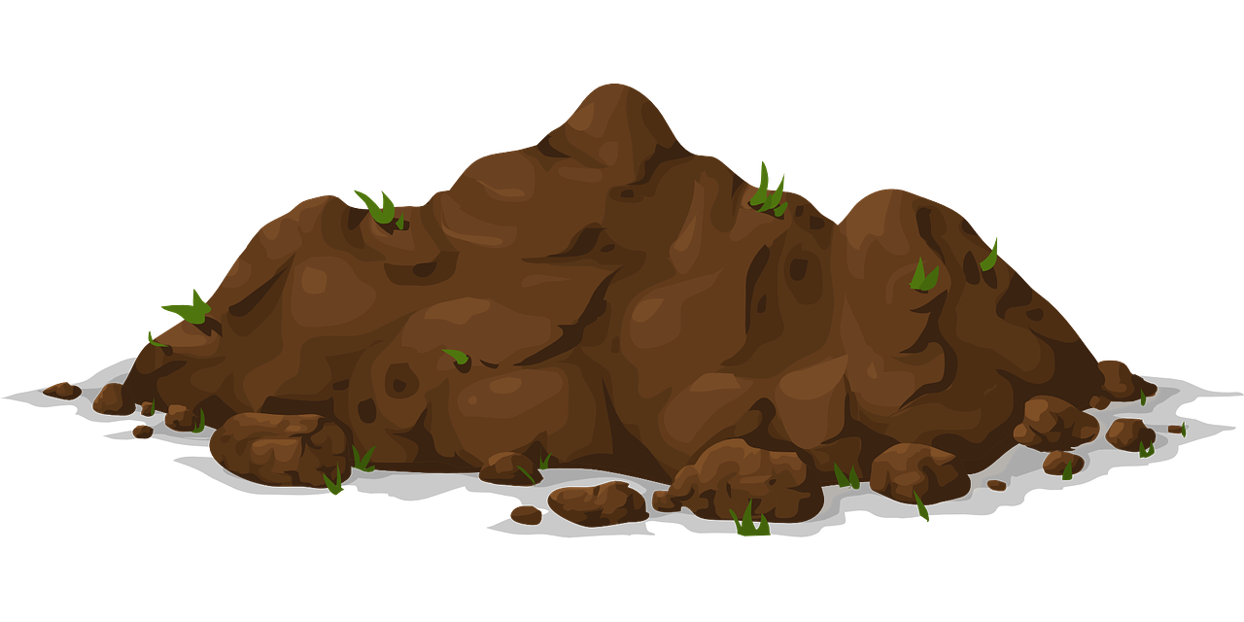

Fruit

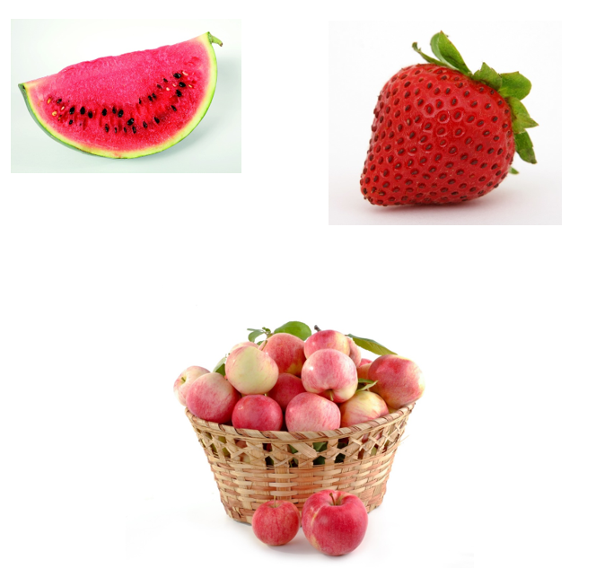Roots

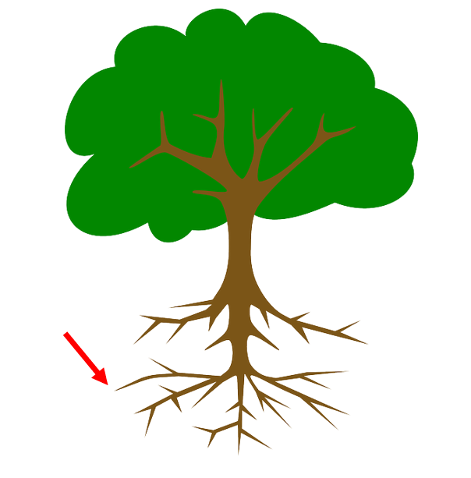

Air

invisible gas surrounding the Earth



Leaf/Leaves

makes food for plants

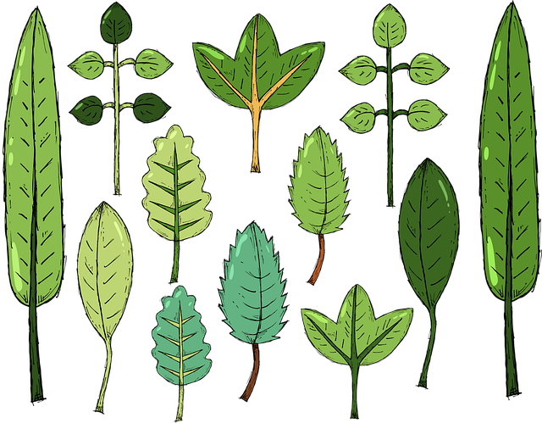

Water

colorless, odorless liquid

Stem

moves water up the plant

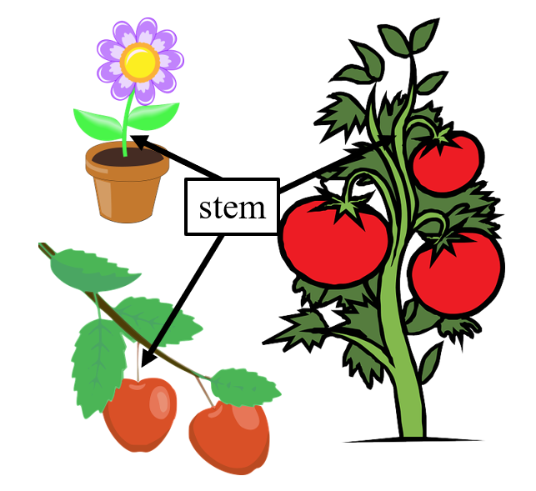

Seeds

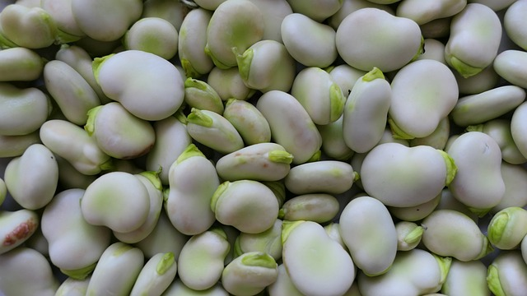

Reproduce

to make new individuals that are similar

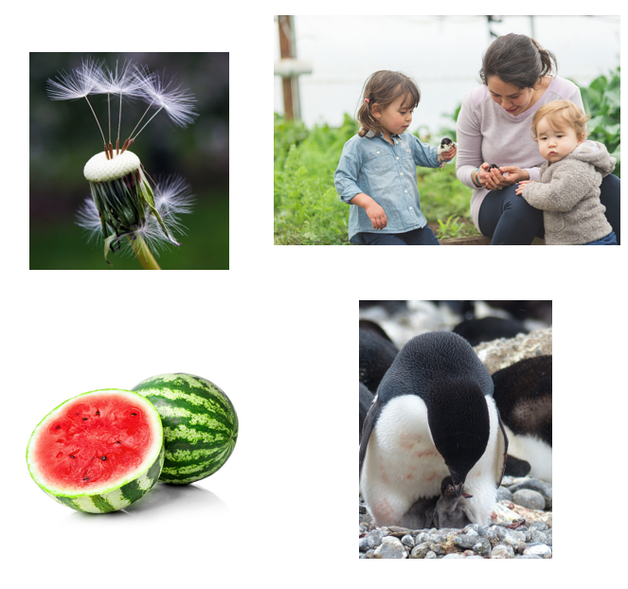

Nutrients

helps living things survive and grow

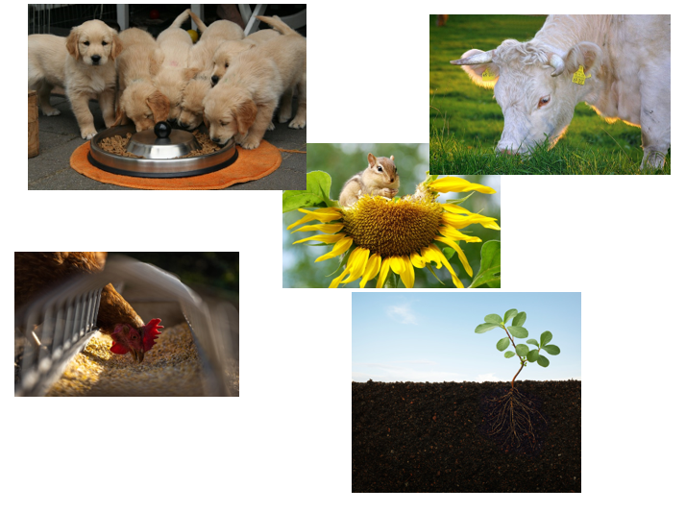

**Supplemental Materials:**

**Living/Non-living Sort**

**pictures read top to bottom, left to right.
first row, palm tree, dog, book,
second row, hat, school, flower,
last row, lady bug car, fish**

**Diagram of Plant**

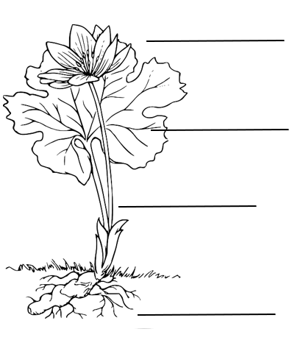

**Diagram of Plant Labeled**

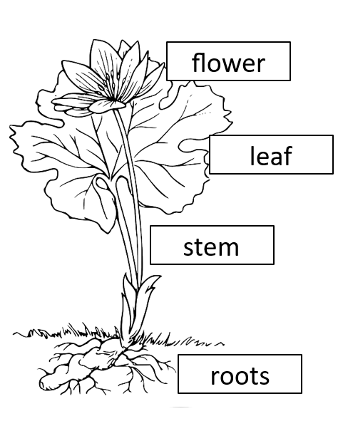

## Plant Part Labels

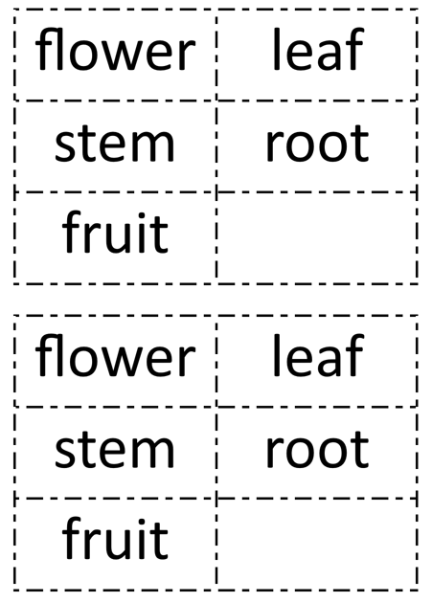

## Plant Functions

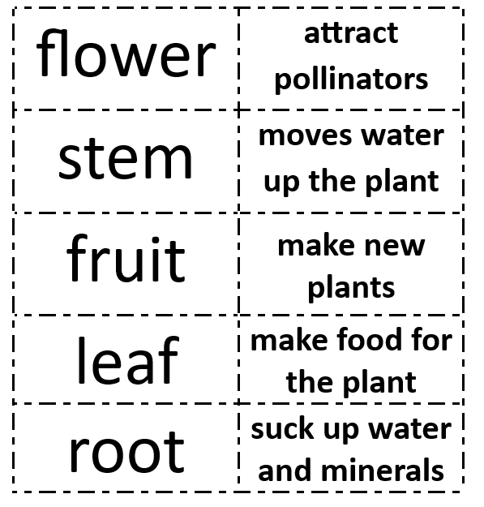

## Reading Questions:

1. Molly plants a flower.

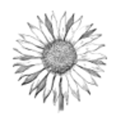

What does Molly plant?

a. flower b. frog c. pumpkin

1. Molly asked her mom to take her to the store.



Who did Molly ask to take her to the store?

a. dog b. dad c. mom

1. Molly knows her flower needs water.



What does Molly’s flower need?

a. fuit b. water c. bug

1. Molly’s flower made her happy.

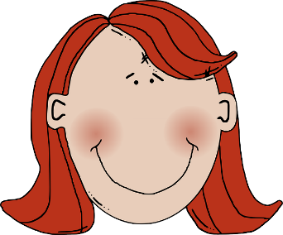

How did Molly’s flower make her feel?

a. happy b. hungry c. honest

## Practice Items:

Item 3
A picture of a mouse
Which does a mouse need to survive?
From left to right
Picture of rocks, rocks
Picture of water, water
Picture of car, car


Item 7
Image of a boy next to a tomato plant.
This is a tomato plant. What would help the tomato plant grow? A. Picture of watering can and plant, watering, B. Picture of a person swimming, swimming, C Picture of a person reading, reading.