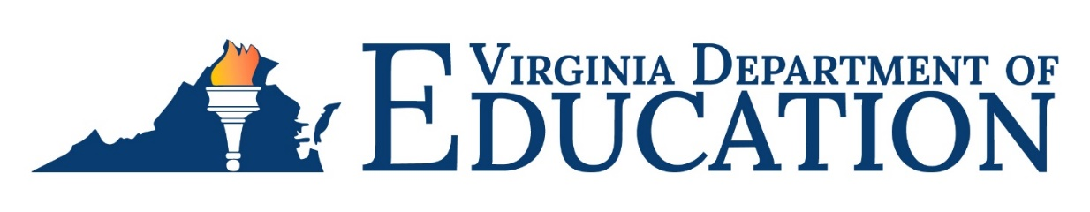

## 2023-2024 National ESEA Distinguished Schools Recognition Program

Virginia has received information regarding the application process for the 2023-2024 National ESEA Distinguished Schools Recognition Program. This project, sponsored by the National Association of ESEA State Program Administrators, recognizes qualifying schools from each state for their outstanding achievements in education. Only two schools per state are selected as National ESEA Distinguished Schools.

An eligible school may be nominated to represent one of the following categories:

* Category 1: Exceptional student performance for two consecutive years;
* Category 2: Closing the achievement gap between student groups; or
* Category 3: Excellence in serving special populations of students (e.g., homeless, migrant, English learners, etc.).

**Eligibility**

In order for a school to qualify for the National ESEA Distinguished School award, the school must have:

1. A poverty rate of at least 35 percent for each of the two most current consecutive school years;
2. Demonstrated exceptional academic achievement for two or more of the most current consecutive school years; and
3. Met full state accreditation for two or more consecutive years.

**Application**

School divisions wishing to nominate a school must submit a complete application and participation form electronically by email to ESSA@doe.virginia.gov by 3:00 p.m., Friday, October 27, 2023. On the email subject line, indicate the school division’s name, name of eligible school, and the category.

**For more information**

If you have questions about the National ESEA Distinguished Schools Recognition Program or application process please contact Latonia Anderson, at Latonia.Anderson@doe.virginia.gov or (804) 750-8173.