SOLU-CORTEF INJECTION, Action Plan

§ 54.1-3408. *Professional use by practitioners*.

*Pursuant to a written order or standing protocol issued by the prescriber within the course of his professional practice, such prescriber may authorize, with the consent of the parents as defined in §*[*22.1-1*](https://law.lis.virginia.gov/vacode/22.1-1/)*, an employee of (i) a school board, (ii) a school for students with disabilities as defined in §*[*22.1-319*](https://law.lis.virginia.gov/vacode/22.1-319/)*licensed by the Board of Education, or (iii) a private school accredited pursuant to §*[*22.1-19*](https://law.lis.virginia.gov/vacode/22.1-19/)*as administered by the Virginia Council for Private Education who is trained in the administration of injected medications for the treatment of adrenal crisis resulting from a condition causing adrenal insufficiency to administer such medication to a student diagnosed with a condition causing adrenal insufficiency when the student is believed to be experiencing or about to experience an adrenal crisis. Such authorization shall be effective only when a licensed nurse, nurse practitioner, physician, or physician assistant is not present to perform the administration of the medication*.

Name _________________________ Sex___ DOB_________

Grade________ School____________________________

Is this information in students 504/IEP? __Yes __No Date_________

Parent Contact information:

1. Name ________________________________________Phone # (____)__________
2. Name ________________________________________Phone # (____)__________

**Treatment for Adreno-Cortical Insufficiency: Solu-Cortef Injection (Procedure)**

**Student may not remain in or return to school the day after emergency treatment.**

|  |
| --- |
| Supplies: Medication, syringe, needles, and alcohol wipes, gloves, and sharps container.  Location of Supplies: ___________________________ |

For one or more checked symptoms below, administer Solu-Cortef __________ ml. immediately.

🞏Severe illness 🞏Fever > 100 degrees F 🞏Shortness of Breath

🞏Trauma 🞏Chills 🞏Irregular Heart Beat

🞏Sudden confusion 🞎Unconsciousness 🞏Other _______________

Action Steps:

**Call for help and 911**. If possible, direct staff to contact parent.

Verify medication orders, child’s name, dose and route of administration.

Press down on plastic activator to force diluent into lower compartment.

Shake gently to mix solution. USE SOLUTION ONLY IF CLEAR.

5. Remove plastic cap covering center of stopper. Once protective cap is removed do not touch top of

stopper.

6. Take plastic cap off needle. Insert needle through center of stopper until tip is visible.

7. Turn bottle upside down and withdraw correct dose as per medication authorization.

(*If any air in the syringe, turn needle upward and gently tap on syringe. Push air out by gently pushing on plunger until you get a drop of solution. )*

8. Apply gloves (optional), cleanse injection site on upper arm or mid-thigh with alcohol pad.

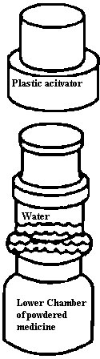 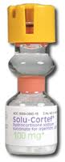

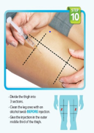

9. Insert needle straight into injection site and inject all medication into site.

10. Dispose syringe in Sharps Container.

11. Call parent.

12. Document on the Medication Chart (SS/SE-46) report to EMS-911.

Time given: _______

School Nurse­­­­______________________ Date: _____________