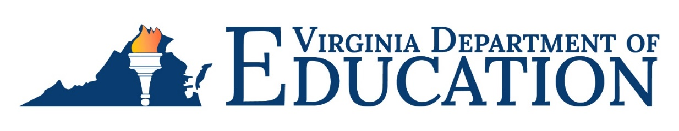

## SUBJECT: 2024 Title I, Part D, Subpart 2, Count of Children who are Neglected or Delinquent (N or D) in School Divisions

Each year, the U.S. Department of Education (USED) requires that all State Education Agencies conduct the Annual Report of Children in Institutions for Neglected or Delinquent Children, Adult Correctional Institutions, and Community Day Programs for Neglected or Delinquent Children. This annual report provides USED with current information on the location and number of children who live in local institutions for neglected or delinquent children, or who are in local adult correctional facilities. The information will be used by USED to calculate the 2025-2026 allocations for programs that serve neglected children through Title I, Part A, or delinquent children through Title I, Part D.

This year the Annual October Count will be reported using the **Annual October Count of Neglected and Delinquent Students Application in the Single Sign-on for Web Systems (SSWS)**. Below are instructions to complete the Title I, Part D, Subpart 2, count of children deemed neglected or delinquent in school divisions. Title I, Part D, coordinators should work with local SSWS administrators to gain access to the application. The window to enter data into SSWS will be open from **Wednesday, October 9, 2024, through Friday, November 29, 2024**.

The [Reporting Tip Sheet for Identifying Eligible Institutions and Counting Children](https://covgov-my.sharepoint.com/:w:/r/personal/gueringe_richardson_doe_virginia_gov/Documents/2023%20Reporting%20Tip%20Sheet%20for%20Identifying%20Eligible%20Institutions%20and%20Counting%20Children%20(1).docx?d=we3a3278397c34c0d963fffc7e3b186c4&csf=1&web=1&e=DlLMu2)  provides information about identifying eligible institutions and children, and instructions for completing the annual count based on the October 2024 caseload data. The information collected locally should notinclude neglected or delinquent children enrolled in state-operated programs (SOP) or the Department of Juvenile Justice (DJJ) institutions. The count must reflect the following:

* the number of children, ages 5-17, inclusive, who live in:

1. local institutions for neglected children as defined in section 1432(4)(A) of the *Elementary and Secondary Education Act* (ESEA), as amended;
2. local institutions for delinquent children as defined in section 1432(4)(B) of the ESEA, as amended, or
3. local adult correctional institutions as defined in section 1432(1) of the ESEA, as amended;

* children who resided in an eligible institution for at least one day during a 30 consecutive day period, at least one day of which falls within the month of October 2024; and
* children who reside in a facility in the geographic boundaries of the school division, including students that have never attended a school in your school division.
* Do not count students from your school division that attend facilities in other school divisions.

[Virginia Department of Education Instructions for Local Educational Agencies using the Annual October Count of Neglected and Delinquent Children Application in SSWS](https://covgov-my.sharepoint.com/:w:/r/personal/gueringe_richardson_doe_virginia_gov/Documents/Virginia%20Department%20of%20Education%20%20%20Instructions%20for%20State%20Educational%20Agencies%20using%20the%20Annual%20October%20Count%20of%20Neglected%20and%20Delinquent%20Children%20Application%20in%20SSWS.docx?d=wdc106f5c2aed49d3bc9f350ba938127d&csf=1&web=1&e=a8McjF) provides directions for entering information into the Annual October Count application. The information submitted will be the same as in previous years and will indicate the total number of neglected and delinquent children and youth the sources for this total.

All school divisions must submit the October Count using the Annual October Count Application in SSWS, even if numbers being reported are zero, by **Friday, November 29, 2024**. If you have questions, please contact Gueringe’ Richardson, Title I, Part A/D, Specialist, at [Gueringe.Richrardson@doe.virginia.gov](mailto:Gueringe.Richrardson@doe.virginia.gov) or (804) 750-8146.