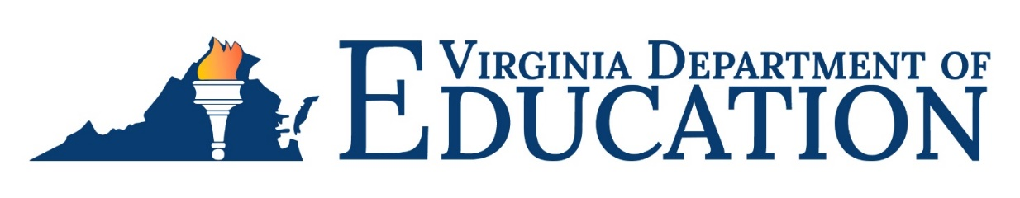

## 2024-2025 Title IV, Part A, Required Federal Reporting

In compliance with the Elementary Secondary Education Act of 1965 (ESEA), as amended by the Every Student Succeed Act of 2015 section 4104(a)(2), the Local Education Agency (LEA) must report to the State on the degree to which it has made progress toward meeting objectives and outcomes in the approved Title IV, Part A application. In addition, State Education Agencies (SEA) have the responsibility of publicly reporting the degree to which the LEAs have made progress toward meeting the objectives and outcomes.

The Virginia Department of Education has developed the Title IV, Part A Submission application to collect the federally required data and produce a report for public viewing. Divisions access the application through the Single Sign-On Web Systems (SSWS). Individuals entering the data obtain access by contacting their SSWS Account Manager designated for their respective school division.

Reporting will be conducted this year for the FY 2022 Title IV, Part A awards. The collection window of the divisions’ objectives and outcomes for the FY 2022 ESEA application will begin on Monday, September 3, 2024, and close on Friday, October 25, 2024.

All school divisions, including those that transfer 100% of Title IV, Part A funds to another federal program, must report in the Title IV, Part A Submission application.

* School divisions that transfer 100% of their funds to another federal program are required to report in the SSWS application the federal programs to which their funds were transferred.
* School divisions that expend a portion of their Title IV, Part A award are required to report the following information:
  + The federal program to which a portion of the award was transferred, if applicable.
  + For the funds remaining in the Tile IV, Part A award,
    - The objectives as written and approved in the most recent approved ESEA application.
    - The level of progress made for each objective as “Met or Exceeded”, “Progressing Toward”, or “Not Met” based upon data that supports the selection.
    - A description for each objective that uses data identified by the division in the objective that supports the selected level of progress.
    - The Title IV, Part A category supported by the objective (well-rounded education, safe and healthy students, and effective use of technology).

The division superintendent or designee must electronically verify the report in SSWS for final submission.

A webinar on the Title IV, Part A Submission application will be conducted on Thursday, September 19, 2024, at 1:30 p.m. via Zoom. Use the following information to access the webinar:

* Zoom meeting: [Title IV, Part A Federal Reporting](https://doe-virginia-gov.zoom.us/j/83941910587?pwd=fGC3yR4BLGnycZn6GMLWQpbR3RWFbH.1)
* Meeting ID: 839 4191 0587
* Passcode: 303554

For questions regarding the Title IV, Part A, federal reporting should be directed to Marsha Granderson, Title IV Coordinator, at [Marsha.Granderson@doe.virginia.gov](mailto:Marsha.Granderson@doe.virginia.gov) or (804) 750-8752.