Date: September 20, 2023
To: All Approved Child Care Subsidy Vendors in Virginia
Copy: Local Directors, Child Care Local Case Managers and Supervisors, DSS Regional Practice Consultants, Ready Regions, Child Care Aware
From: Clifton Wise, Child Care Coordinator, VDOE
Amanda Kay, Child Care Subsidy Program Manager, VDSS

Subject: Child Care Subsidy Program Update to the Oct. 1, 2022 Vendor Agreement, Paid Child Absences Have Increased
Dear Child Care Subsidy Provider,

You are receiving this letter because your site participates in the Child Care Subsidy Program (CCSP). Pursuant to the Code of Virginia §§ 22.1-289.03 and 22.1-289.046, VDOE has the authority to set policies for the CCSP. Accordingly, this letter provides notification of an update to the number of paid child absences.

Effective August 3, 2023, paid child absences increased from 36 paid absences to 60 paid absences per child, per fiscal year (the fiscal year is June 1 - May 31). This increase is a result of the CCSP’s ongoing efforts to support vendors like you who provide Child Care Subsidy Programming for your community.

If your program no longer wishes to be a CCSP provider due to this increase of services, you can opt out at any time by contacting Vendor Relations at vendor.manager@dss.virginia.gov.

Additionally, reminders to vendors of attendance policies as well as guidance for planned and unplanned closure days were sent in June 2023 via email [showdocument (virginia.gov)]. Please be sure to review this guidance. If you have any questions about attendance policies, please send them to vendor.manager@dss.virginia.gov.

Thank you for your participation in the Child Care Subsidy Program and for your continued service to children and families.

Sincerely,
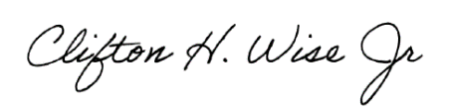
Clifton H. Wise Jr.
Child Care Operations Coordinator
Office of Early Childhood Access and Enrollment
Virginia Department of Education

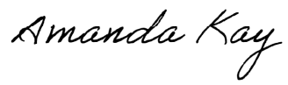
Amanda Kay
Child Care Subsidy Program Manager
Division of Benefit Programs
Virginia Department of Social Services

